**DEAL DESK**

**TECHNICAL DESIGN DOCUMENT**

|  |  |
| --- | --- |
| **File Name** | Project Lexmark Big Machines Integration – Solution Document |
| **Version** | V1 |
| **Document Owner** | Deloitte |
| **Creation Date** | 6th April 2013 |

**Revision History:**

| **Version** | **Revision Date** | **Author(s)** | **Revision Notes** |
| --- | --- | --- | --- |
| V1 | 06/04/2013 | Sri Swathi Kiran | Initial Config Draft |
| V2 | 24/04/2013 | Vamsidhar Poosarla | Updated Commerce Calculations and related documentation |
| V3 | 26/04/2013 | Joshna Reddy Palla | Updated document with Approval flows and Security |

**Document Sign- Off / Evidence of Review:**

With this acknowledgement, the undersigned hereby agree to the form, content and overall integrity of the accompanying document.

Each section of this document has been thoroughly reviewed by technical, business leads and subject matter expert groups that have communicated their support for the document content to each of the signatories listed below. Signatories, in turn, are those individuals that speak on behalf of their respective subject matter experts, technical and business leads.

| **Version** | **Date** | **Approved By:** | **Notes** |
| --- | --- | --- | --- |
|  |  |  |  |
|  |  |  |  |

Document Properties

This document provides the configuration, commerce, approval process and customization settings that have been implemented for the Project Lexmark Big Machines Integration. This configuration and customization will serve as the base for a full release.

## Related Documentation

* **Requirements:**This dataset lists the business requirements - including the functional, interface, data conversion and reporting requirements for the Big Machines implementation. The requirement list is used to facilitate estimating the effort required to design, build, test and implement the solution. The document also provides the necessary information required to define the business and technical level of effort, analyze gaps with the out-of-the-box solution, and propose an approach to meet each business requirement.

Location:

* **Data Dictionary:** This dataset contains the list of all the attributes that are used in the system to implement the required functionality and to meet the proposed requirements.

Location: Lexmark_BigMachines_DataDictionary

* **Use Cases:**

Location:

* **To – Be Processes:**

Location

Table of Contents

Document Properties 4

Related Documentation 4

1. Config 9

1.1 High-Level Data Model 9

1.2 Product Hierarchy 9

1.3 Configuration Rules 11

1.3.1 Hiding Attributes 11

1.3.2 Recommendations 11

1.3.3 Constraints 11

1.3.4 Recommended Items 12

1.4 Lexmark 12

1.4.1 Attributes in Lexmark Configurator 12

1.4.2 Hiding Rules In LexMark Configurator 15

1.4.3 Recommendation Rules In Lexmark Configurator 31

1.4.4 Constraint rules In Lexmark Configurator 40

1.4.5 Recommended Items Rule in Lexmark Configurator 43

1.5 Master Agreement 45

1.5.1 Attributes In Master Agreement Configurator 45

1.5.2 Hiding Rules In Master Agreement Configurator 46

1.5.3 Recommendation Rules in Master Agreement Configurator 49

1.5.4 Constraint Rules in Master Agreement Configurator 52

1.5.5 Recommended Items Rule in Master Agreement Configurator 53

1.6 Partner Selection 54

1.6.1 Attributes In Partner Selection Configurator 54

1.6.2 Hiding Rules in Partner Selection Configurator 57

1.6.3 Recommendation Rules in Partner Selection Configurator 60

1.6.4 Constraint Rules in Partner Selection COnfigurator 72

1.6.5 Recommended Items Rule In Partner Selection Configurator 76

2. Commerce 77

2.1 Sales Information 77

2.2 Quote Category 78

2.2.1 Quote Category Flow 78

2.2.2 Quote Category Attributes in BM: 79

2.3 Pricing & Cals 79

2.3.1 Datatable Lookups 80

2.3.2 Part Calculations 81

2.3.3 Model Calculations 82

2.3.4 Total Calculations 86

2.4 Page Calculations 89

2.5 Party Tables 90

2.6 Requestor History table 90

2.7 Summary P & L Table 92

2.8 Actions 92

2.9 Master – Participant Quote 93

2.10 Constraint on Start and End Date 97

3. Approval Process 98

3.1 Approval tree Classification 98

3.2 Reason Trees 99

3.2.1 Special Bid MPS 99

3.2.2 Special Bid Channel 100

3.2.3 Special Bid Traditional – HW Only 103

3.2.4 Special Bid Traditional – Supplies Only 105

3.2.5 Promotions – Hw and Supplies 107

3.2.6 MDF, VIR, LR and Price Protection 109

3.2.7 Quote Analyst 111

3.2.8 Approval Reason Matrix 112

3.2.9 How Do They Work Together? 112

3.3 Watchers and Approvers 113

3.4 Adhoc Approvers 114

3.5 Approval Related Attributes 116

3.6 Reason Rejection 116

3.7 Pending Approvers and Approval History 119

3.8 Util Libraries 120

3.8.1 Populate Approval Category 120

3.8.2 Get User Details 120

3.8.3 Reset Optional Approvers 120

3.8.4 Fetch User Group Based on Geo 120

3.8.5 Populate Approval History 121

3.8.6 Is Quote Approved By All Levels 121

3.8.7 Populate Approval Status On Quote 121

3.8.8 Reset Quote Approval Status 121

3.8.9 Populate Pending Approvals 121

3.8.10 Pending Approvals HTML Table 121

3.8.11 Fetch Approver Email Ids 122

3.9 Commerce Libraries 122

3.9.1 Get Approver List 122

3.9.2 Get Approver Groups ListFetch Approver Email Ids 122

3.10 Data Tables 122

3.11 Reporting Strings 123

3.12 Email Notifications 123

4. Security Controls 126

4.1 Participant Profiles 126

4.2 User Groups 126

4.3 Steps 127

4.4 User Access Rights 127

4.4.1 Performer Steps 127

4.4.2 Groups 127

4.5 Auto Forwarding Rules 128

1. Config

## 1.1 High-Level Data Model

The high-level data model defines the underlying data structure for the Lexmark Big Machines implementation. It basically consists of three configurators: **Lexmark**, **Master Agreement** and **Partner Selection**.

## 1.2 Product Hierarchy

Lexmark inventory is referred with two terms: **Products** and **Materials.** Every part that is sold or put on a quote is called a **Material.** All materials are mapped to a product structure. Lexmark’s product structure is defined with a four level hierarchy: Line, Series, Family and Model. Model is the unique value in the hierarchy with a product line, series and family describing its structure. The diagram below illustrates the hierarchical relationship:

Products are categorized into the following lines:

* Printers
* Options
* Supplies
* Service Parts
* Services
* Solutions Software
* Warranty

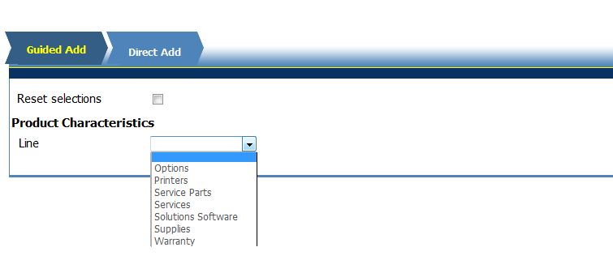

## 1.3 Configuration Rules

Configuration Rules allow us to suggest product configuration values to Sales Rep using recommendation rules or hide some configurable attributes from users.

Rules can also be used to recommend parts to Sales Rep and/ or prevent them from selecting opposing values of configurable attributes and display additional information.

Configuration Rule Types are presented below:

### 1.3.1 Hiding Attributes

Hiding Attributes, also known as Hiding Rules, hide attributes when a pre –defined condition is met.

### 1.3.2 Recommendations

Recommendation Rules helps in displaying the product/part numbers that the Sales Rep would like to select or the products Sales Rep has to select.

### 1.3.3 Constraints

Constraint Rules prevent the Sales Rep from selecting items he is not supposed.

### 1.3.4 Recommended Items

Recommended Items are used to assign parts to the configuration based on Sales Rep selections during the configuration process.

## 1.4 Lexmark

Lexmark helps the Sales Rep to add part numbers based on the requirement. The Sales Rep, when he knows the valid part number for his Sales Org, can directly enter the Part number and get the details of the product.

Lexmark configurator has three tabs namely: **Guided Add, Direct Add and Line Series Discounting.**

Guided Add provides the Sales Rep with all the associated fields to a particular Product Line so that the required and valid part number can be added to the quote.

### 1.4.1 Attributes in Lexmark Configurator

| Attribute Name | Variable Name | Data Type |
| --- | --- | --- |
| Physical Material Or Financial Material Number? | physicalMaterialOrFinancialMaterialNumber | Single Select Menu |
| Financial Material Number | financialMaterialNumber | Multi Select Menu |
| Line | productLine | Single Select Menu |
| Series | printersSeries | Single Select Menu |
| Family | printersFamily | Single Select Menu |
| Series | suppliesSeries | Single Select Menu |
| Family | suppliesFamily | Single Select Menu |
| Model | suppliesModel | Single Select Menu |
| Series | optionsSeries | Single Select Menu |
| Family | optionsFamily | Single Select Menu |
| Model | optionsModel | Single Select Menu |
| Series | servicesSeries | Single Select Menu |
| Family | servicesFamily | Single Select Menu |
| Model | servicesModel | Single Select Menu |
| Series | warrantySeries | Single Select Menu |
| Family | warrantyFamily | Single Select Menu |
| Model | warrantyModel | Single Select Menu |
| Series | servicePartsSeries | Single Select Menu |
| Family | servicePartsFamily | Single Select Menu |
| Model | servicePartsModel | Single Select Menu |
| Series | solutionsSoftwareSeries | Single Select Menu |
| Family | solutionsSoftwareFamily | Single Select Menu |
| Model | solutionsSoftwareModel | Single Select Menu |
| Related Printer Series | relatedPrinterSeries | Single Select Menu |
| Related Printer Family | relatedPrinterFamily | Single Select Menu |
| Related Printer Model | relatedPrinterModel | Single Select Menu |
| Show related materials for selected printer | quoteRelatedProducts | Boolean |
| Division | Division | Single Select Menu |
| Brand Name | brandName | Single Select Menu |
| User Segment | userSegment | Single Select Menu |
| Options Group | optionsGroup | Single Select Menu |
| Options Type | optionsType | Single Select Menu |
| Finishing Capability | finishingCapability | Single Select Menu |
| Color/Black | printersType | Single Select Menu |
| Page Format | pageFormat | Single Select Menu |
| Printers Function | printersFunction | Single Select Menu |
| Service Parts Group | servicePartsGroup | Single Select Menu |
| Service Parts Type | ServicePartsType | Single Select Menu |
| Services Type | servicesType | Single Select Menu |
| Services Group | servicesGroup | Single Select Menu |
| ISS Software | solutionsSoftwareType | Single Select Menu |
| Solutions Software Category | solutionsSoftwareCategory | Single Select Menu |
| Solutions Software Channel | solutionsSoftwareChannel | Single Select Menu |
| Supplies Group | suppliesGroup | Single Select Menu |
| Supplies Type | suppliesType | Single Select Menu |
| PI Yield UOM | pIYieldUOM | Single Select Menu |
| Cartridge Type | suppliesProductClass | Single Select Menu |
| Supplies Yield | suppliesYieldClass | Single Select Menu |
| Warranty Duration | warrantyDuration | Single Select Menu |
| Warranty Response Type | warrantyResponseType | Single Select Menu |
| Consummable Type | consummableType | Single Select Menu |
| Voltage | voltage | Single Select Menu |
| SPR indicator | sPRIndicator | Single Select Menu |
| Offering | offering | Single Select Menu |
| Brand Name | materialBrandName | Single Select Menu |
| PS&Software Technical Check list | pSSoftwareTechnicalCheckList | Text |
| Printer selection | productSelection | Boolean |
| Printer # | productName | Text |
| Printer Description | productDescription | Text |
| Supplies selection | suppliesSelection | Boolean |
| Supplies # | suppliesName | Text |
| Supplies Description | suppliesDescription | Text |
| PI Yield | pIYield_Supplies | Text |
| Options selection | optionsSelection | Boolean |
| Options Name | optionsName | Text |
| Options Description | optionsDescription | Text |
| Warranties selection | warrantiesSelection | Boolean |
| Warranties Name | warrantiesName | Text |
| Warranties Description | warrantiesDescription | Text |
| Warranties Category | warrantiesCategory | Single Select Menu |
| Service selection | serviceSelection | Boolean |
| Service Name | serviceName | Text |
| Service Description | serviceDescription | Text |
| Software selection | softwareSelection | Boolean |
| Software Name | softwareName | Text |
| Software Description | softwareDescription | Text |
| ServiceParts selection | servicePartsSelection | Boolean |
| ServiceParts Name | servicePartsName | Text |
| ServiceParts Description | servicePartsDescription | Text |
| Category | category | Single Select Menu |
| Cost | cost | Currency |
| Price | price | Currency |
| Show more filters | guidedSearch | Boolean |
| Number of Parts | noOfParts | Integer |
| Part Number : | partNo | Text |
| Description (Add Parts) | description_addParts | Text |
| Description | description | Single Select Menu |
| Part Number | partNumber | Text |
| Reset selections | resetSelections | Boolean |
| TAA Compliant | taaCompliants | Single Select Menu |
| Line Series Discounting | vIRDiscounting | Integer |
| Line | lineVistex | Single Select Menu |
| Series | seriesVistex | Single Select Menu |
| Payout | payoutVistex | Float |
| Target | targetVistex | Float |
| Target Type | targetType | Single Select Menu |
| Payout Type | payoutType | Single Select Menu |
| Reset Selections | resetSelections_directAdd | Boolean |
| Sales Group | salesGroup | Text |
| Quote Type | quoteType | Text |
| Quote Category | quoteCategory | Text |
| 3rd Party Product | a3rdPartyProduct | Text |
| Program Type | programType | Text |
| Please input your Parts String | pleaseInputYourPartsString | Text Area |

### 1.4.2 Hiding Rules In LexMark Configurator

| **Name of the Hiding Rule** | **Condition Summary** | **Attribute(s) to be hidden** |
| --- | --- | --- |
| Hide Product Line | ((((Quote Category Not = "Promotion") AND (Quote Category Not = "Special Bid Traditional") AND (Quote Category Not = "Special Bid MPS") AND (Quote Category Not = "SPIFF") AND (Quote Category Not = "Price Protection") AND ((Quote Category Not = "MDF") AND (Physical Material Or Financial Material Number? = "Physical Material [Physical Material]")) AND ((Quote Category Not = "VIR") AND (Physical Material Or Financial Material Number? = "Physical Material [Physical Material]")) AND ((Quote Category Not = "Logistics") AND (Physical Material Or Financial Material Number? = "Physical Material [Physical Material]"))) OR (Physical Material Or Financial Material Number? = "Financial Material Number [Financial Material Number]")) OR ((Quote Category = "MDF") AND (Physical Material Or Financial Material Number? = ""))) OR ((Quote Category = "VIR") AND (Physical Material Or Financial Material Number? = "")) | 1. Line [productLine] 2. Number of Parts [noOfParts] 3. Part Number : [partNo] 4. Description (Add Parts) [description_addParts] 5. Reset Selections [resetSelections_directAdd] |
| Hide Adhoc Array based on Quote Category | Quote Category Not = "Special Bid MPS" | 1. Category [category] 2. Cost [cost] 3. Price [price] 4. Description [description] 5. Part Number [partNumber] |
| Hide Attributes if Quote Category is not MDF | Quote Category Not= "MDF" | 1. Activity [activity] 2. Sub - Activity [subActivity] 3. Show more filter [guidedSearch] |
| Hide select all printers based on quote category | (Quote Category = "Special Bid") OR (Line Not = "Printers [Printers]") | 1. Select All Printer [selectAllPrinters] |
| Hide attribute if product line is not selected | (Line = "") | 1. Division [Division] 2. Brand Name [brandName] 3. User Segment [userSegment] 4. Show more filters [guidedSearch] |
| Hide Voltage based on Product Line | (Line = "" OR "Supplies [Supplies]") OR ((Line Not = "Options [Options]") AND (Line Not = "Printers [Printers]")) | 1. Voltage [voltage] |
| Hide Attributes when Product Line is not Supplies or Options | (Line Not = "Options [Options]" OR "Supplies [Supplies]") | 1. Related Printer Series [relatedPrinterSeries] 2. Related Printer Family [relatedPrinterFamily] 3. Related Printer Model [relatedPrinterModel] 4. Related Printer Name [relatedPrinterName] |
| Hide Attributes when Product Line is not Options | (Line = "") OR (Line Not = "Options [Options]") | 1. Series [optionsSeries] 2. Family [optionsFamily] 3. Name [optionsName_ProductTaxonomy] 4. Options Group [optionsGroup] 5. Options Type [optionsType] |
| Hide Attributes when Product Line is not Service Parts | (Line = "") OR (Line Not = "Service Parts [Service Parts]") | 1. Series [servicePartsSeries] 2. Family [servicePartsFamily] 3. Model [servicePartsModel] 4. Name [servicePartsName_ProductTaxonomy] 5. Service Parts Group [servicePartsGroup] 6. Service Parts Type [servicePartsType] 7. Consummable Type [consummableType] |
| Hide Attributes if Product Line is not Supplies | (Line Not = "Supplies [Supplies]") OR (Line = "") | 1. Series [suppliesSeries] 2. Family [suppliesFamily] 3. Name [suppliesName_ProductTaxonomy] 4. Supplies Group [suppliesGroup] 5. Supplies Type [suppliesType] 6. PI Yield UOM [pIYieldUOM] 7. Cartridge Type [suppliesProductClass] 8. Supplies Yield [suppliesYieldClass] |
| Hide Attributes if Product Line is not Warranty | (Line Not = "Warranty [Warranty]") OR (Line = "") | 1. Series [warrantySeries] 2. Family [warrantyFamily] 3. Name [warrantyName] 4. Warranty Duration [warrantyDuration] 5. Warranty Response Type [warrantyResponseType] 6. Offering [offering] |
| Hide Attributes when Product Line is not Services | (Line = "") OR (Line Not = "Services [Services]") | 1. Series [servicesSeries] 2. Family [servicesFamily] 3. Name [serviceName_ProductTaxonomy] 4. Services Type [servicesType] 5. Services Group [servicesGroup] |
| Hide Attributes if Product Line is Not Printers | (Line Not = "Printers [Printers]") OR (Line = "") | 1. Series [printersSeries] 2. Family [printersFamily] 3. Name [printersName] 4. Show related materials for selected printer [quoteRelatedProducts] 5. Finishing Capability [finishingCapability] 6. Color/Black [printersType] 7. Page Format [pageFormat] 8. Printers Function [printersFunction] 9. SPR Indicator [sPRIndicator] 10. TAA Compliant [tAAComplaints] |
| Hide Product Filter attributes if Product Name or Model is not empty | ((Line = "Printers [Printers]") AND ((Name Not = "") OR (Model Not = ""))) OR ((Line = "Options [Options]") AND ((Name Not = "") OR (Model Not = ""))) OR ((Line = "Warranty [Warranty]") AND ((Name Not = "") OR (Model Not = ""))) OR ((Line = "Services [Services]") AND ((Name Not = "") OR (Model Not = ""))) OR ((Line = "Solutions Software [Solutions Software]") AND ((Name Not = "") OR (Model Not = ""))) OR ((Line = "Service Parts [Service Parts]") AND ((Name Not = "") OR (Model Not = ""))) | 1. Division [Division] 2. Brand Name [brandName] 3. User Segment [userSegment] 4. Options Group [optionsGroup] 5. Options Type [optionsType] 6. Finishing Capability [finishingCapability] 7. Color/Black [printersType] 8. Page Format [pageFormat] 9. Printers Function [printersFunction] 10. Service Parts Group [servicePartsGroup] 11. Service Parts Type [servicePartsType] 12. Services Type [servicesType] 13. Services Group [servicesGroup] 14. ISS Software [solutionsSoftwareType] 15. Solutions Software Category [solutionsSoftwareCategory] 16. Solutions Software Channel [solutionsSoftwareChannel] 17. Supplies Group [suppliesGroup] 18. Supplies Type [suppliesType] 19. PI Yield UOM [pIYieldUOM] 20. Cartridge Type [suppliesProductClass] 21. Supplies Yield [suppliesYieldClass] 22. Warranty Duration [warrantyDuration] 23. Warranty Response Type [warrantyResponseType] 24. Consummable Type [consummableType] |
| Hide Material Brand Name based on Product Filters | ((Cartridge Type Not = "Private Label [Private Label]") AND (Division Not = "Perceptive") AND ((Series Not = "MPS [MPS]") AND (Family Not = "Competitor Products [Competitor Products]") AND (Line Not = "Professional_Services_and_Solution_Software")) AND (Line = "")) OR ((Cartridge Type Not = "Private Label [Private Label]")) | 1. Brand Name [materialBrandName] |
| Hide Financial Material Number based on Physical Material | (Physical Material Or Financial Material Number? Not = "Financial Material Number [Financial Material Number]") | 1. Financial Material Number [financialMaterialNumber] |
| Hide Physical Material Or Financial Material Number based on Quote | (Quote Category Not = "VIR") AND (Quote Category Not = "Logistics") AND (Quote Category Not = "MDF") | 1. Physical Material Or Financial Material Number [physicalMaterialOrFinancialMaterialNumber] |
| Hide Product Array if No. of Products is < 1 | (productLine == "Printers") AND (noOfProducts > 0) | 1. Show related materials for selected printer [quoteRelatedProducts] 2. Printer Selection [productSelection] 3. Printer # [productName] 4. Printer Description [productDescription] 5. Unannounced Flag [unannouncedFlag] 6. Geo Average Volume [wWAverageVolume] 7. Monthly Mono Page Volume [monthlyMonoPageVolume] 8. Monthly Color Page Volume [monthlyColorPageVolume] 9. Total Page Volume [totalPageVolume] |
| Hide Software Array if No. of Softwares is < 1 | ((productLine <> "") AND (productLine == "Printers" AND quoteRelatedProducts)) OR (productLine == "Solutions Software") | 1. Software Selection [softwareSelection] 2. Software Name [softwareName] 3. Software Description [softwareDescription] 4. Software Line [softwareLine] |
| Hide Services Array if No. of Services is < 1 | ((productLine <> "") AND (productLine == "Printers" AND quoteRelatedProducts)) OR (productLine == "Services") | 1. Service Selection [serviceSelection] 2. Service Name [serviceName] 3. Service Description [serviceDescription] 4. Service Line [serviceLine] |
| Hide service parts array based on no of service parts | (No. of ServiceParts < 1) OR (Line = "") OR (ServiceParts Name = "") | 1. ServiceParts selection [servicePartsSelection] 2. ServiceParts Name [servicePartsName] 3. ServiceParts Description [servicePartsDescription] 4. ServiceParts Line [servicePartsLine] |
| Hide Options array based on No of Options | ((productLine <> "") AND (productLine == "Printers" AND quoteRelatedProducts)) OR (productLine == "Options") | 1. Options Selection [optionsSelection] 2. Options Name [optionsName] 3. Options Description [optionsDescription] 4. Options Line [optionsLine] |
| Hide PS&Software Technical Check list | ((Line Not = "Professional_Services_and_Solution_Software") AND (Line Not = "Services [Services]") AND (Line Not = "Solutions Software [Solutions Software]")) | 1. PS&Software Technical Check List [pSSoftwareTechicalCheckList] |
| Hide attributes if Product line is not Sol s/w | (Line = "") OR (Line Not = "Solutions Software [Solutions Software]") | 1. Series [solutionsSoftwareSeries] 2. Family [solutuonsSoftwareFamily] 3. Name [solutionsSoftwareName] 4. Division [Division] 5. ISS Software [solutionsSoftwareType] 6. Solutions Software Category [solutionsSoftwareCategory] 7. Solutions Software Channel [solutionsSoftwareChannel] |
| Hide Quote Category if blank | (Quote Category = "") | 1. Quote Category [quoteCategory] |
| Hide 3rd Party Product if blank | (3rd Party Product = "") | 1. 3rd Party Product [a3rdPartyProduct |
| Hide Program Type if blank | (Program Type = "") | 1. Program Type [programType] |
| Hide printer model when printer name is not empty | (Name Not = "") OR (Line Not = "Printers [Printers]") | 1. Model [printersModel] |
| Hide supplies model when supplies name is not empty | (Name Not = "") OR (Line Not = "Supplies [Supplies]") | 1. Model [suppliesModel] |
| Hide options model when options name is not empty | (Name Not = "") OR (Line Not = "Options [Options]") | 1. Model [optionsModel] |
| Hide warranty model when warranty name is not empty | (Name Not = "") OR (Line Not = "Warranty [Warranty]") | 1. Model [warrantyModel] |
| Hide services model when services name is not empty | (Name Not = "") OR (Line Not = "Services [Services]") | 1. Model [servicesModel] |
| Hide solution software model when solution software name is not empty | (Name Not = "") OR (Line Not = "Solutions Software [Solutions Software]") | 1. Model [SolutionsSoftwareModel] |
| Hide printer name when printer model is not empty | (Model Not = "") | 1. Name [printersName] |
| Hide supplies name when supplies model is not empty | (Model Not = "") | 1. Name [suppliesName_ProductTaxonomy] |
| Hide options name when options model is not empty | (Model Not = "") | 1. Name [optionsName_ProductTaxonomy] |
| Hide warranty name when warranty model is not empty | (Model Not = "") | 1. Name [warrantyName] |
| Hide solution software name when solution software model is not empty | (Model Not = "") | 1. Name [solutionsSoftwareName] |
| Hide services name when services model is not empty | (Model Not = "") | 1. Name [servicesName_ProductTaxonomy] |
| Hide Brand Name when Material Brand Name is Empty | (Cartridge Type = "Private Label [Private Label]") | 1. Brand Name [brandName] |
| Hide filter attributes if Guided Search is false | (Show more filters = False) | 1. Name [printersName] 2. Series [suppliesSeries] 3. Family [suppliesFamily] 4. Name [suppliesName_ProductTaxonomy] 5. Series [optionsSeries] 6. Family [optionsFamily] 7. Name [optionsName_ProductTaxonomy] 8. Series [servicesSeries] 9. Family [servicesFamily] 10. Name [servicesName_ProductTaxonomy] 11. Series [warrantySeries] 12. Family [warrantyFamily] 13. Name [warrantyName] 14. Series [servicePartsSeries] 15. Family [servicePartsFamily] 16. Name [servicePartsName_ProductTaxonomy] 17. Series [solutionsSoftwareSeries] 18. Family [solutionsSoftwareFamily] 19. Name [solutionsSoftwareName] 20. Brand Name [brandName] 21. User Segment [userSegment] 22. Options Group [optionsGroup] 23. Options Type [optionsType] 24. Finishing Capability [finishingCapability] 25. Color/Black [printersType] 26. Page Format [pageFormat] 27. Printers Function [printersFunction] 28. Service Parts Group [servicePartsGroup] 29. Service Parts Type [servicePartsType] 30. PI Yield UOM [pIYieldUOM] 31. Cartridge Type [suppliesProductClass] 32. Supplies Yield [suppliesYieldClass] 33. Warranty Duration [warrantyDuration] 34. Warranty Response Type [warrantyResponseType] 35. Consummable Type [consummableType] 36. Voltage [voltage] 37. SPR Indicator [sPRIndicator] 38. Offering [offering] 39. Brand Name [materialBrandName] 40. TAA Compliant [taaCompliants] |
| Hide Guided search based on physical material or financial material number | (Physical Material Or Financial Material Number? = "Financial Material Number [Financial Material Number]") | 1. Show more filters [guidedSearch] |
| Hide error message based on diplay error attribute | (Display Error = False) | 1. Error Message [errorMessage] |
| Hide array based on line | (Line Not = "") AND (Model = "") AND (Model = "") AND (Model = "") AND (Model = "") AND (Model = "") AND (Model = "") AND (Model = "") AND (Show more filters = False) | 1. Printer Selection [productSelection] 2. Printer # [productName] 3. Printer Description [productDescription] 4. Unannounced Flag [unannouncedFlag] 5. Geo Average Volume[wWAverageVolume] 6. Monthly Mono Page Volume [monthlyMonoPageVolume] 7. Monthly Color Page Volume [monthlyColorPageVolume] 8. Total Page Volume [totalPageVolume] |
| Hide service parts name when service parts model is not empty | (Model Not = "") | 1. Name [servicePartsName_ProductTaxonomy] |
| Hide service parts model when service parts name is not empty | (Name Not = "") | 1. Model [servicePartsModel] |
| Hide attributes if product line is Supplies | (Line = "Supplies [Supplies]") | 1. User Segment [userSegment] 2. Supplies Type [suppliesType] 3. PI Yield UOM [pIYieldUOM] |
| Hide Line Series Discounting | ( (quoteCategory <> "VIR") AND (quoteCategory <> "Promotion") AND (quoteCategory <> "Special Bid Traditional") AND (quoteCategory <> "Special Bid MPS") AND (quoteCategory <> "Special Bid Channel")) OR ( (quoteCategory == "Special Bid Traditional" OR quoteCategory == "Special Bid MPS" OR quoteCategory == "Special Bid Channel") AND areYouProvidingLineSeriesDiscounting=="No") | 1. Line Series Discounting [vIRDiscounting] 2. Line [lineVistex] 3. Series [seriesVistex] 4. Payout [payoutVistex] 5. Target Type [targetType] 6. Payout Type [payoutType] 7. Target [targetVistex] |
| Hide Supplies Array based on No of supplies | ((productLine <> "") AND (productLine == "Printers" AND quoteRelatedProducts)) OR (productLine == "Supplies") | 1. Supplies Selection [suppliesSelection] 2. Supplies # [suppliesName] 3. Supplies Description [suppliesDescription] 4. PI Yield [pIYield_Supplies] |
| Hide Line Series Discounting Attrs | (Quote Category = "Promotion") OR (Quote Category = "Special Bid Traditional") OR (Quote Category = "Special Bid MPS") OR (Quote Category = "Special Bid Channel") | 1. Payout [payoutVistex] 2. Target [targetVistex] 3. Target Type [targetType] 4. Payout Type [payoutType] |
| Hide Direct Add and Guided Add tabs if QC is Special Bid and Line Series Discount is Yes | (((Quote Category = "Special Bid MPS") OR (Quote Category = "Special Bid Channel") OR (Quote Category = "Special Bid Traditional")) AND (Are you providing Line Series Discounting ? = "Yes [Yes]")) | All the attributes in Guided Add and Direct Add tabs |
| Hide Warranties array based on no of warranties | ((productLine <> "") AND (productLine == "Printers" AND quoteRelatedProducts) OR (productLine == "Warranty")) | 1. Warranties selection [warrantiesSelection] 2. Warranties Name [warrantiesName] 3. Warranties Description [warrantiesDescription] 4. division Warranties [divisionWarranties] 5. Warranties Category [warrantiesCategory] 6. Warranties Line [warrantiesLine] |

### 1.4.3 Recommendation Rules In Lexmark Configurator

| Name of the rule | Condition Summary | Attributes to be set |
| --- | --- | --- |
| Set all arrays to blank value | Always true | 1. noofProducts = 1 2. productName = string[] 3. productDescription = string[] 4. noOfSupplies = 1 5. suppliesName = string [] 6. suppliesDescription = string [] 7. noOfOptions = 1 8. optionsName = string [] 9. optionsDescription = string [] 10. noOfWarranties = 1 11. warrantiesName = string [] 12. warrantiesDescription = string [] 13. warrantiesCategory = Standard 14. noOfServices = 1 15. noOfSotwares = 1 16. softwareName = string [] 17. softwareDescription = string [] 18. softwareName = string [] 19. softwareDescription = string [] 20. noOfServiceParts = 1 21. servicePartsName = string [] 22. servicePartsDescription = string [] 23. guidedSearch = true or false 24. displayError = False |
| Set Product line based on program type | (Program Type = "Star") | 1. productLine = Supplies |
| Set Product Array and related Product Arrays | (Line = "Printers [Printers]") AND (Show related materials for selected printer = True) AND ((Model Not = "") OR (Family Not = "") OR (Name Not = "") OR (Series Not = "") OR (Brand Name Not = "") OR (Page Format Not = "") OR (Color/Black Not = "") OR (Voltage Not = "") OR (Finishing Capability Not = "") OR (Printers Function Not = "") OR (User Segment Not = "") AND (TAA Compliant Not = "")) | 1. noOfProducts 2. printersInfo_InternalAttr 3. productName 4. productDescription 5. totalPageVolume 6. noOfSupplies 7. suppliesName 8. suppliesDescription 9. pIYield_Supplies 10. noOfOptions 11. optionsName 12. optionsDescription 13. noOfWarranties 14. warrantiesName 15. warrantiesDescription 16. noOfServices 17. serviceName 18. serviceDescription 19. noOfSoftware 20. softwareName 21. softwareDescription |
| set printers array when quote related products is false | (Line = "Printers [Printers]") AND (Show related materials for selected printer = False) AND ((Model Not = "") OR (Family Not = "") OR (Series Not = "") OR (Name Not = "") OR (Brand Name Not = "") OR (Page Format Not = "") OR (Color/Black Not = "") OR (TAA Compliant Not = "") OR (Voltage Not = "") OR (Finishing Capability Not = "") OR (Printers Function Not = "") OR (User Segment Not = "")) | 1. noOfProducts 2. printersInfo_InternalAttr 3. productName 4. productDescription 5. displayError 6. errorMessage |
| Set Supplies Array | (Line = "Supplies [Supplies]") AND (Related Printer Series = "") AND (Related Printer Family = "") AND (Related Printer Model = "") AND (Related Printer Name = "") AND ((Series Not = "") OR (Model Not = "") OR (Name Not = "") OR (Family Not = "") OR (Brand Name Not = "") OR (Supplies Yield Not = "") OR (Cartridge Type Not = "") OR (Supplies Group Not = "")) | 1. noOfSupplies 2. suppliesName 3. suppliesDescription 4. pIYield_Supplies 5. displayError 6. errorMessage |
| Set options array | (Line = "Options [Options]") AND (Related Printer Series = "") AND (Related Printer Family = "") AND (Related Printer Model = "") AND (Related Printer Name = "") AND ((Voltage Not = "") OR (Model Not = "")) | 1. noOfOptions 2. optionsName 3. optionsDescription 4. displayError 5. errorMessage |
| Set Warranties Array | (Line = "Warranty [Warranty]") AND ((Model Not = "") OR (Family Not = "") OR (Name Not = "") OR (Voltage Not = "") OR (Warranty Response Type Not = "") OR (User Segment Not = "") OR (Warranty Duration Not = "") OR (Offering Not = "")) | 1. noOfWarranties 2. warrantiesName 3. warrantiesDescription 4. displayError 5. errorMessage |
| Set Services Array | (Line = "Services [Services]") AND ((Voltage Not = "") OR (User Segment Not = "") OR (Services Type Not = "") OR (Services Group Not = "") OR (Series Not = "") OR (Family Not = "") OR (Model Not = "") OR (Name Not = "") OR (Brand Name Not = "")) | 1. noOfServices  2. serviceName 3. serviceDescription 4. displayError 5. errorMessage |
| Set Software Array | (Line = "Solutions Software [Solutions Software]") AND ((Model Not = "") OR (Series Not = "") OR (Family Not = "") OR (Name Not = "") OR (ISS Software Not = "") OR (Voltage Not = "") OR (Brand Name Not = "") OR (User Segment Not = "") OR (Solutions Software Channel Not = "") OR (Solutions Software Category Not = "") OR (Division Not = "")) | 1. noOfSoftwares 2. softwareName 3. softwareDescription 4. displayError 5. errorMessage |
| Set attributes if Product line is Sol s/w | (Line = "") OR (Line Not = "Solutions Software [Solutions Software]") | 1. Division = ISS |
| Recommend Part Description based on Part number | (Part Number : Not = "") | description_addParts |
| Part number based on adhoc array description | Always true | 1. partNumber |
| Reset all product characteristics | (Reset selections = True) | 1. productLine = "" 2. printersSeries = "" 3. printersFamily = "" 4. printersModel = "" 5. printersName = "" 6. suppliesSeries = "" 7. suppliesFamily = "" 8. suppliesModel = "" 9. suppliesName_ProductTaxonomy = "" 10. optionsSeries = "" 11. optionsFamily = "" 12. optionsModel = "" 13. optionsName_ProductTaxonomy = "" 14. servicesSeries = "" 15. servicesFamily = "" 16. servicesModel = "" 17. servicesName_ProductTaxonomy = "" 18. warrantySeries = "" 19. warrantyFamily = "" 20. warrantyModel = "" 21. warrantyName = "" 22. servicePartsSeries = "" 23. servicePartsFamily = "" 24. servicePartsModel = "" 25. servicePartsName_ProductTaxonomy = "" 26. solutionsSoftwareSeries = "" 27. solutionsSoftwareFamily = "" 28. solutionsSoftwareModel = "" 29. solutionsSoftwareName = "" 30. quoteRelatedProducts = ""  31. Division = "" 32. brandName = "" 33. userSegment = "" 34. optionsGroup = "" 35. finishingCapability = "" 36. printersType = "" 37. pageFormat = "" 38. printersFunction = "" 39. servicePartsGroup = "" 40. ServicePartsType = "" 41. servicesType = "" 42. servicesGroup = "" 43. solutionsSoftwareType = "" 44. solutionsSoftwareChannel = "" 45. suppliesGroup = "" 46. suppliesType = "" 47. pIYieldUOM = "" 48. suppliesProductClass = "" 49. warrantyDuration = "" 50. warrantyResponseType = "" 51. consummableType = "" 52. voltage = "" 53. sPRIndicator = "" 54. offering = "" 55. materialBrandName = "" 56. noOfProducts = 1 57. productName = String [] 58. productDescription = String [] 59. noOfSupplies = 1 60. suppliesName = string [] 61. suppliesDescription = string [] 62. noOfOptions = 1 63. optionsName = string [] 64. optionsDescription = String [] 65. noOfWarranties = 1 66. warrantiesName = string [] 67. warrantiesDescription = string [] 68. noOfServices = 1 69. serviceName = string [] 70. serviceDescription = string [] 71. noOfSoftwares = 1 72. softwareName = String [] 73. softwareDescription = string [] 74. noOfServiceParts = 1 75. servicePartsName = String [] 76. servicePartsDescription = String [] 77. Cost = "" 78. price 79. howManyAdhocItems = 1 80. guidedSearch = False 81. description  82. partNumber  83. resetSelections = False |
| Set supplies array based on related printers | ((productLine=="Supplies")) AND ( ((relatedPrinterSeries<>"")) OR ((relatedPrinterFamily<>"")) OR ((relatedPrinterName<>"")) OR ((relatedPrinterModel<>"")) )) | 1. noOfSupplies 2. suppliesName 3. suppliesDescription 4. pIYield_Supplies 5. displayError 6. errorMessage |
| Set options array based on related printers | (Line = "Options [Options]") AND ((Related Printer Series Not = "") OR (Related Printer Family Not = "") OR (Related Printer Model Not = "") OR (Related Printer Name Not = "")) | 1. noOfOptions 2. optionsName 3. optionsDescription 4. displayError 5. errorMessage |
| Set service parts array | (Line = "Service Parts [Service Parts]") AND ((Voltage Not = "") OR (User Segment Not = "") OR (Service Parts Group Not = "") OR (Service Parts Type Not = "") OR (Consummable Type Not = "") OR (Series Not = "") OR (Family Not = "") OR (Model Not = "")) | 1. noOfServices  2. serviceName 3. serviceDescription 4. displayError 5. errorMessage |
| Set warranties category | ((division Warranties = "ISS") AND ((Warranties Description Contains "Customized") OR (Warranties Description Contains "NBD") OR (Warranties Description Contains "Special Bid") OR (Warranties Description Contains "Management Fees"))) OR (division Warranties = "Perceptive") | 1. warrantiesCategory = Customized |
| Reset direct add | (Reset Selections = True) | 1. noOfParts = 1 2. partNo = String [ ] 3. description_addParts = string [] 4. quantity = string [] |

### 1.4.4 Constraint rules In Lexmark Configurator

| Name of the Constraint Rule | Condition Summary | (Constrain/Allow) | Variable Name |
| --- | --- | --- | --- |
| Product series based on printer product line | (Line = "Printers [Printers]") | Allow | printersSeries |
| Product series based on Supplies product line | (Line = "Supplies [Supplies]") | Allow | suppliesSeries |
| Options Series based on options product line | (Line = "Options [Options]") | Allow | optionsSeries |
| Warranty Series based on warranty product line | (Line = "Warranty [Warranty]") | Allow | warrantySeries |
| Services Series based on services product line | (Line = "Services [Services]") | Allow | servicesSeries |
| Sol Software Series based on Sol Software product line | (Line = "Solutions Software [Solutions Software]") | Allow | solutionsSoftwareSeries |
| Printer Family based on printers series | (Series Not = "") AND (Line = "Printers [Printers]") | Allow | printersFamily |
| Supplies Family based on supplies series | (Series Not = "") AND (Line = "Supplies [Supplies]") | Allow | suppliesFamily |
| Options Family based on options series | (Series Not = "") AND (Line = "Supplies [Supplies]") | Allow | optionsFamily |
| Warranty Family based on warranty series | (Series Not = "") AND (Line = "Warranty [Warranty]") | Allow | warrantyFamily |
| Services Family based on services series | (Series Not = "") AND (Line = "Services [Services]") | Allow | servicesFamily |
| Sol Software family based on sol software series | (Series Not = "") AND (Line = "Solutions Software [Solutions Software]") | Allow | solutionsSoftwareFamily |
| Printers Model Based On Printers Family | (Family Not = "") AND (Line = "Printers [Printers]") | Allow | printersModel |
| Supplies Model Based On Supplies Family | (Family Not = "") AND (Line = "Supplies [Supplies]") | Allow | suppliesModel |
| Options Model Based on Options Family | (Family Not = "") AND (Line = "Options [Options]") | Allow | optionsModel |
| Warranty Models Based On Warranty Family | (Family Not = "") AND (Line = "Warranty [Warranty]") | Allow | warrantyModel |
| Service Models Based On Service Family | (Family Not = "") AND (Line = "Services [Services]") | Allow | servicesModel |
| Solution Software Models Based On Solution Software Family | (Family Not = "") AND (Line = "Solutions Software [Solutions Software]") | Allow | solutionsSoftwareModel |
| Printer Name Based On Printer Family | (Line = "Printers [Printers]") AND (Family Not = "") | Allow | printersName |
| Supplies Name Based On Supplies Family | (Family Not = "") AND (Line = "Supplies [Supplies]") | Allow | suppliesName_ProductTaxonomy |
| Options Name Based On Options Family | (Family Not = "") AND (Line = "Options [Options]") | Allow | optionsName_ProductTaxonomy |
| Warranty Name Based On Warranty Family | (Family Not = "") AND (Line = "Warranty [Warranty]") | Allow | warrantyName |
| Services Name Based On Services Family | (Family Not = "") AND (Line = "Warranty [Warranty]") | Allow | serviceName_ProductTaxonomy |
| Solution Software Name Based On Solutions Software Family | (Family Not = "") AND (Line = "Solutions Software [Solutions Software]") | Allow | solutionsSoftwareName |
| Constraint Product Line if Program Type is Edge | (Program Type = "Edge") | Allow | productLine |
| Allow supplies when program type equals 'Star' | (Program Type = "Star") | Allow | productLine = Supplies |
| Brand Name based on product line | (Line Not = "") | Allow | brandName |
| Constrain number of printers selected | (quoteRelatedProducts == true) | Allow | productSelection = True |
| Service Parts Name Based On Service Parts Family | (Family Not = "") AND (Line = "Service Parts [Service Parts]") | Allow | servicePartsName_ProductTaxonomy |
| Service Parts Family based on Service Parts series | (Series Not = "") AND (Line = "Service Parts [Service Parts]") | Allow | servicePartsFamily |
| Service Parts Model Based On Service Parts Family | (Family Not = "") AND (Line = "Service Parts [Service Parts]") | Allow | servicePartsModel |
| Service Parts Series based on Service Parts product line | (Line = "Service Parts [Service Parts]") | Allow | servicePartsSeries |
| Part Number - One Printer to be Added from Direct Add | (partNo Not = "") AND noofParts <> 1 | Constrain | noOfParts > 1 |

### Recommended Items Rule in Lexmark Configurator

| Name of the Rule | Condition Summary |
| --- | --- |
| Recommend Parts based on Product Array | (noOfProducts >= 1 AND productLine == "Printers") |
| Recommend Parts based on Supplies Array | (noOfSupplies >= 1 AND (productLine == "Supplies" OR (productLine == "Printers" AND quoteRelatedProducts) |
| Recommend Parts based on Options Array | optionsSelection <> "" |
| Recommend Parts based on Services Array | (noOfServices >= 1 AND (productLine == "Services" OR (productLine == "Printers" AND quoteRelatedProducts)) |
| Recommend Parts based on Warranties Array | (noOfWarranties >= 1 AND (productLine == "Warranty" OR (productLine == "Printers" AND quoteRelatedProducts)) |
| Recommend Parts based on Softwares Array | (noOfSoftwares >= 1 AND (productLine == "Solutions Software" OR (productLine == "Printers" AND quoteRelatedProducts)) |
| Recommend Parts Based On Financial Material Number Attribute Selections | (Financial Material Number Not = "") |

## 1.5 Master Agreement

Master Agreement Configurator is used by the Sales Rep to create a Master quote such that the parts added to the master quote are added to the related participating quote.

### 1.5.1 Attributes In Master Agreement Configurator

| Attribute Name | Variable Name | Data Type |
| --- | --- | --- |
| No.Of Participating Countries | noOfParticipatingCountries | Integer |
| Country | mastercountry | Single Select Menu |
| No.Of Master Quote Parts | noOfMasterQuoteParts | Integer |
| Part Number | masterPartNumber | Text |
| Exchange Rate | exchangeRate | Float |
| Description (Master) | masterDescription | Text |
| No.Of Participant Quote Parts | noOfParticipantQuoteParts | Integer |
| Qty (Master) | masterPartQuantity | Integer |
| Bid Price (Master) | masterPartBidPrice | Float |
| FLOD (Master) | masterFLOD | Float |
| Part Number (Participant) | partcPartNumber | Text |
| Description (Partcipant) | partcDescription | Text |
| Qty (Participant) | participantQty | Integer |
| Converted Bid Price | partcConvertedBidPrice | Float |
| Participant Country Currency | participantCountryCurrency | Single Select Menu |
| Exchange Rate | exchangeRatePartcCountries | Float |
| Participating Quote Currency | participatingQuoteCurrency | Text |
| Participating Quote Country | participatingQuoteCountry | Single Select Menu |
| Master Quote Country | masterQuoteCountry | Single Select Menu |
| Master Quote Currency | masterQuoteCurrency | Single Select Menu |
| FLOD | fLOD_participant | Float |
| Please paste your MasterAgreement XML | importMasterAgreementXML | Text |
| Sales Office | salesOffice | Text |
| Country Name to Country Code String | countryNameToCountryCodeString | Text |
| CountryCode To CountryName String | countryCodeToNameStr_MasterAgreement | Text |
| Sales Group | salesGroup | Text |
| Quote Type | quoteType | Text |
| participantCountryAndCurrencySet_Quote | participantCountryAndCurrencySet_Quote | Text Area |
| Sales Organization | salesOrganization | Text |

### 1.5.2 Hiding Rules In Master Agreement Configurator

| Name of the Hiding Rule | Condition Summary | Attribute(s) to be hidden |
| --- | --- | --- |
| Hide Quote Type if blank | (Quote Type = "") | 1. Quote Type [quoteType] |
| Hide Scheme if blank | (Scheme = "") | 1. Scheme [selectScheme] |
| Hide Participant attributes when quote type equals master | (Quote Type = "Master") OR ((Import MasterAgreement = "true") AND (Quote Type Not = "Participant")) | 1. Participating Quote Country [participatingQuoteCountry] 2. No.Of Participating Quote Parts [noOfParticipantQuoteParts] 3. Part Number (Participant) [partcPartNumber] 4. Description (Participaint) [partcDescription] 5. Qty (Participant) 6. Participating Quote Currency [participatingQuoteCurrency] 7. Exchange Rate [exchangeRate] 8. Converted Bid Price [partcConvertedBidPrice] |
| Hide attributes for Participant Quote Type | (Quote Type = "Participant") | 1. No.Of Participating Countries [noOfParticipatingCountries] 2. No.Of Master Quote Parts [noOfMasterQuoteParts] |
| Hide participant quote array based on participant county | (Participating Quote Country = "") | 1. No.Of Participant Quote Parts [noOfParticipantQuoteParts] 2. Part Number (Participant) [partcPartNumber] 3. Description (Participant) [partcDescription] 4. Qty (Participant) [partcipantQty] 5. FLOD [fLOD_participant] 6. Converted Bid Price [partcConvertedBidPrice] |
| Import Master Agreement | (Import MasterAgreement = "true") AND (Please paste your MasterAgreement XML = "") | 1. Quote Type [quoteType] 2. Participating Quote Country [participatingQuoteCountry] 3. No.Of Partcipating Countries [noOfParticipatingCountries] 4. No.Of Master Quote Parts [noOfMasterQuoteParts] 5. Country [masterCountry] 6. Part Number [masterPartNumber] 7. Description (master) [masterDescription) 8. No.Of Participant Quote Parts [noOfParticipantQuoteParts] 9. Qty (Master) [masterPartQuantity] 10. Bid Price (Master) [masterPartBidPrice] 11. FLOD (Master) [masterFLOD] 12. Part Number (Participant) [partcPartNumber] 13. Description (Participant) [partcDescription] 14. Qty (Participant) [participantQty] 15. Participating Quote Currency [participantQuoteCurrency] 16. Participating Country Currency [participatingCountryCurrency] 17. Exchange Rate [exchangeRatePartcCountries] 18. FLOD (fLOD_participant] 19. Exchange Rate [exchangeRate] 20. Converted Bid Price [partcConvertedBidPrice] 21. Master Quote Country [masterQuoteCountry] 22. Master Quote Currency [masterQuoteCurrency] |

### 1.5.3 Recommendation Rules in Master Agreement Configurator

| Name of the rule | Condition Summary | Attributes to be set |
| --- | --- | --- |
| Set Quote attributes from Commerce | Always true | 1. salesOrganization 2. salesOffice 3. salesRegion 4. salesGroup 5. salesGeo 6. quoteType  7. participantCountryAndCurrencySet_quote 8. quoteCategory  9. a3rdPartyproduct  10. programType 11. parsingAttrParticipatingCountry 12. searchResults 13. contractTermInMonths 14. sessionCurrency 15. CSsearchResults 16. areYouProvidingLineSeriesDiscounting 17. quoteApprovalStatus |
| CountryCode To CountryName String | Always true | 1. countryCodeToNameStr_MasterAgreement =" countryCode $$ salesRegionCountry@@" 2. countryNameToCountryCodeString = "salesRegionCountry$$countryCode@@" |
| set participanting countries array | (participantCountryAndCurrencySet_Quote <> "" AND len(participantCountryAndCurrencySet_Quote) > 0) | 1. noOfParticipatingCountries 2. masterCountry  3. participantCountryCurrency  4. exchangeRatePartcCountries |
| Participant Country Arr For Master Quote Import | (Import MasterAgreement = "true") AND (Please paste your MasterAgreement XML Not = "") AND (participantCountryAndCurrencySet_Quote = "") | 1. noOfParticipatingCountries 2. masterCountry |
| auto populate master country and currency | Always true | 1. participatingQuoteCurrency 2. participatingQuoteCountry 3. isParticipatingCountrySet 4. masterQuoteCountry 5. masterQuoteCurrency |
| set participant quote currency and exchange rate | (Quote Type = "Participant") | 1. participatingQuoteCurrency 2. exchangeRate |
| EX Rate of Participating Country Currencies | ((Quote Type = "Master") AND (parsing Attr Participating country = "")) OR (Import MasterAgreement = "true") | 1. exchangeRatePartcCountries |
| set Master FLOD | ((noOfMasterQuoteParts > 1 OR (noOfMasterQuoteParts == 1 AND masterPartNumber[1] <> "")) AND quoteType <> "") | 1.masterFLOD |
| Set Participant FLOD | (noOfParticipantQuoteParts > 1 OR (noOfParticipantQuoteParts == 1 AND len(partcPartNumber[0]) > 0) | 1. fLOD_participant |
| Auto fill master quote parts based on Part number | (Part Number Not = "") | 1. masterDescription 2. masterPartQuantity |
| Participant array based on master quote array | (No.Of Master Quote Parts >= 1) AND (Quote Type = "Participant") | 1. noOfParticipatingCountries 2. noOfMasterQuoteParts 3. masterCountry 4. masterPartNumber 5. masterDescription 6. noOfParticipantQuoteParts 7. masterPartQuantity 8. masterPartBidPrice 9. masterFLOD 10. partcPartNumber 11. partcDescription 12. participantQty 13. participantCountryCurrency 14. exchnageRatePartCountries 15. partcConvertedBidPrice 16. masterQuoteCurrency 17. masterQuoteCountry 18. approvedBidPrice |
| Import MasterAgreement Master Parts Array | (participantCountryAndCurrencySet_Quote = "") AND (Import MasterAgreement = "true") AND (Please paste your MasterAgreement XML Not = "") | 1. noOfMasterQuoteParts  2. masterPartNumber 3. masterPartQuantity 4. masterPartBidPrice |

### 1.5.4 Constraint Rules in Master Agreement Configurator

|  |  |  |  |
| --- | --- | --- | --- |
| Name of the Constraint Rule | Condition Summary | (Constrain/Allow) | Variable Name |
| Participating Quote Country based on Participating countries array | (Quote Type = "Participant") | Allow | participatingQuoteCountry |
| Participant Country Currency | (Quote Type = "Master") OR ((Import MasterAgreement = "true") AND (Please paste your MasterAgreement XML Not = "")) | Allow | participantQuoteCurrency |

### 1.5.5 Recommended Items Rule in Master Agreement Configurator

|  |  |
| --- | --- |
| Name of the Rule | Condition Summary |
| Recommend Parts based on Master Quotes Array | (quoteType=="Master" AND (noOfMasterQuoteParts > 1 OR (noOfMasterQuoteParts == 1 AND (NOT(isempty(masterPartNumber))) |
| Recommend Parts based on Participant Quotes Array | (quoteType == "Participant" AND len(participatingQuoteCountry) > 0 AND (noOfParticipantQuoteParts> 1 OR (noOfParticipantQuoteParts== 1 AND (NOT(isempty(partcPartNumber)))) |

## 1.6 Partner Selection

Partners and End User Customers are added by the Sales Rep for the fulfillment of the quote.

There are three tabs in the Partner Selection configurator namely: **Partner Selection, End User Customer Selection** and **Account Creation.**

### 1.6.1 Attributes In Partner Selection Configurator

The following are the fields in the Partner Selection Configurator that helps the Sales Rep add the respective Partners and End User Customers to the quote:

| Attribute Name | Variable Name | Data Type |
| --- | --- | --- |
| Quote Sub Category | quoteSubCategory | Text |
| Sales Geo | salesGeo | Text |
| Quote Type | quoteType | Text |
| Quote Category | quoteCategory | Text |
| No of Partners | noOfPartners | Integer |
| Selected ID | sAPSoldTo | Text |
| Trans Acct Name | transAcctName | Text |
| Party role | partyRole | Text |
| Party type | partyType | Text |
| Purchasing method (from Lexmark) | purchasingMethod | Single Select Menu |
| Claiming party? | claimingParty | Single Select Menu |
| Ship/Debit | shipDebit | Single Select Menu |
| Printers | printers | Boolean |
| Options | options | Boolean |
| Supplies | supplies | Boolean |
| Service Parts | serviceParts | Boolean |
| Warranty | warranty | Boolean |
| Name | name | Text |
| Services | services | Boolean |
| City | city | Text |
| Software | solSoftware | Boolean |
| MDM Account Number | mDMAccountNumber | Text |
| CRM Key | cRMKey | Text |
| Party Role | partyRoles | Single Select Menu |
| Party Type | partyTypes | Single Select Menu |
| SAP Sold To | sAPSoldsTo | Text |
| HTML Patner Search | hTMLPatnerSearch | HTML Read Only Attribute |
| Search Results : | searchResults | HTML Read Only Attribute |
| Display Error | displayError | Boolean |
| Error message | errorMessage | HTML Read Only Attribute |
| Sales Region | salesRegion | Text |
| Session currency | sessionCurrency | Text |
| City | SAParrayCity | Text |
| Street | SAParrayStreet | Text |
| State | SAParrayState | Text |
| Zip Code | SAParrayZipCode | Text |
| No. of Selectable Customers | noOfSelectableCustomers | Integer |
| Customer Selection IDs | customerSelectionIDs | Text |
| Search Results HTML Msg String | searchResultsHTMLMsgString_Partner | HTML Read Only Attribute |
| HTML Customer Search | hTMLCustomerSearch | HTML Read Only Attribute |
| Search Results HTML Msg String | searchResultsHTMLMsgString_Customer | HTML Read Only Attribute |
| Search Results : | CSsearchResults | HTML Read Only Attribute |
| No. of customers | noOfCustomers | Integer |
| Name | CustomerSelectionName | Text |
| MDM Account Number | CSmDMAccountNumber | Text |
| SAP Sold to / ZIDC | CsSAPSoldTo | Text |
| Selected ID | CSarraySelectedID | Text |
| CRM Key | CScRMKey | Text |
| Country | CScountry | Text |
| City | CScity | Text |
| Party Roles | partyRole_CS | Text |
| Trans Acct Name | CStransAcctName | Text |
| Party Types | CSpartyTypes | Text |
| Timing Of Discount | orderClaim | Single Select Menu |
| Purchasing method | CSarrayPurchasingMethod | Single Select Menu |
| Claiming party | CSclaimingParty | Single Select Menu |
| Printer | CSarryPrinters | Boolean |
| Supplie | CSsupplies | Boolean |
| Service Part | CSserviceParts | Boolean |
| Warrant | CSwarranty | Boolean |
| Service | CSservices | Boolean |
| Softwar | CSsolutionSoftware | Boolean |
| Option | CSoptions | Boolean |
| Count | SAPcountry | Text |
| Stree | CSstreet | Text |
| Countr | CSarrayCountry | Text |
| Cit | CSarrayCity | Text |
| Zip Code | CSarrayZipCode | Text |
| Ship/Debi | CSArrayShipDebit | Single Select Menu |
| Timing Of Discoun | CSArrayOrderClaim | Single Select Menu |
| Stat | CSArrayState | Text |
| Click to Select | partnerSelection | Boolean |
| Country | country_PS | Single Select Menu |
| Country | country_CS | Single Select Menu |
| Street | street_Partner | Text |
| Bid Eligibility | bidEligibility_Partner | Boolean |
| Vistex Eligibility | vistexEligibility_Partner | Boolean |

### 1.6.2 Hiding Rules in Partner Selection Configurator

| Name of the Hiding Rule | Condition Summary | Attributes to be Hidden |
| --- | --- | --- |
| Hide Quote Type if blank | (Quote Type = "") | 1. Quote Type [quoteType] |
| Hide Quote Category if blank | (Quote Category = "") | 1. Quote Category [quoteCategory] |
| Hide Quote Sub Category if blank | (Quote Sub Category = "") | 1. Quote Sub Category [quoteSubCategory] |
| Hide Partner array Party role | (Party role = "") | 1. Party Role [partyRole] |
| hide partner array party type when empty | (Party type = "") | 1. Party Type [partyType] |
| Hide partner array SAP/Vistex when empty | (SAP/VISTEX = "") | 1. SAP/VISTEX [sAPVISTEX] |
| Hide customer array sap/vistex when empty | (SAP/VISTE = "") | 1. SAP/VISTE [CSdestination] |
| Hide customer array party role when empty | (Party Roles = "") | 1. Party Roles [partyRole_CS] |
| Hide customer array party type when empty | (Party Types = "") | 1. Party Types [CSpartyTypes] |
| Hide ship/debit when empty | (Ship/Debit = "") OR (User Groups Contains "Sales region Sales requester group") | Ship/Debit [shipDebit] |
| Hide customer Ship/Debit when empty | (Ship/Debi = "") OR (User Groups Contains "Sales region Sales requester group") | Ship/Debi [CSArrayShipDebit] |
| Hide Ship/Debit when Order/Claim is Order | (Timing Of Discount = "Upfront [Order]") AND (Sales Geo = "EMEA") | Ship/Debit [shipDebit] |
| hide claiming party for sales reps if sales geo not NA | Ship/Debit [shipDebit] | Claiming Party? [claimingParty] |
| Hide Partner Selection |  | Click to Select [partnerSelection] |
| Hide Customer Selection |  | Click to Select [customerSelection] |
| Hide Partner Selection Error Message | (find(searchTableHTML,findMsg2) <> -1) OR (find (searchTableHTML,findMsg1) <> -1) | Search Results HTML Msg String [searchResultsHTMLMsgString_Partner] |
| Hide Customer Selection Error Message | (find (searchTableHTML,findMsg1) <> -1) OR (find(searchTableHTML,findMsg2) | Search Results HTML Msg String [searchResultsHTMLMsgString_Customer] |

### 1.6.3 Recommendation Rules in Partner Selection Configurator

| Name of the rule | Condition Summary | Attributes to be set |
| --- | --- | --- |
| Set partners array and customer array to blank | Always true | 1. transAcctName = String [] 2. partyRole = String [] 3. partyType = String [] 4. shipDebit = String [] 5. hTMLPartnerSearch = "" 6. searchResults = <html> </html> 7. SAPArrayCity = String [] 8. SAPArrayStreet = String [] 9. SAPArrayState = String [] 10. SAPArrayZipCode = String [] 11. noOfSelectableCustomers = 1 12. customerSelectionIDs = string [] 13. hTMLCustomerSearch = "" 14. CSsearchResults = <html> </html>  15. partyRole_CS = String [] 16. CStransAcctName = string [] 17. CSpartyTypes =String [] 18. CSdestination = string [] 20. sAPVISTEX = String [] 21. SAPCountry = String [] 22. CSstreet = String [] 23. CSarrayCountry = String [] 24. CSarrayCity = String [] 25. CSarrayZipCode = String [] 26. CSArrayShipDebit = String [] 27. CSArrayState = String [] 28. noOfSelectablePartners = 1 29. partnerSelection = Boolean [] 30. partnerSelectionIDs = string [] 31. customerSelection = Boolean [] |
| Recommend Search Results | ((City Not = "") OR (Name Not = "") OR (MDM Account Number Not = "") OR (Party Role Not = "") OR (Party Type Not = "") OR (SAP Sold To Not = "") OR (CRM Key Not = "") OR (City Not = "") OR (Name Not = "") OR (MDM Account Number Not = "") OR (SAP Sold to / ZIDC Not = "") OR (CRM Key Not = "") OR (Party Role Not = "") OR (Party Type Not = "") OR (Street Not = "") OR (Street Not = "") OR (Country Not = "") OR (Country Not = "")) | 1. hTMLPartnerSearch  2. searchResults 3. noOfSelectablePartners 4. customerSelectionIDs 5. searchResultsHTMLMsgString_Partner 6. hTMLCustomerSearch 7. searchResultsHTMLMsgString_Customer 8. CSsearchResults 9. noOfSelectablePartners 10. partnerSelectionIDs |
| Set partners array and customer array to blank | Always true | 1. transAcctName = String [] 2. partyRole = String [] 3. partyType = String [] 4. shipDebit = String [] 5. hTMLPartnerSearch = "" 6. searchResults = <html> </html> 7. SAPArrayCity = String [] 8. SAPArrayStreet = String [] 9. SAPArrayState = String [] 10. SAPArrayZipCode = String [] 11. noOfSelectableCustomers = 1 12. customerSelectionIDs = string [] 13. hTMLCustomerSearch = "" 14. CSsearchResults = <html> </html>  15. partyRole_CS = String [] 16. CStransAcctName = string [] 17. CSpartyTypes =String [] 18. CSdestination = string [] 20. sAPVISTEX = String [] 21. SAPCountry = String [] 22. CSstreet = String [] 23. CSarrayCountry = String [] 24. CSarrayCity = String [] 25. CSarrayZipCode = String [] 26. CSArrayShipDebit = String [] 27. CSArrayState = String [] 28. noOfSelectablePartners = 1 29. partnerSelection = Boolean [] 30. partnerSelectionIDs = string [] 31. customerSelection = Boolean [] |
| Update SAP Array with Selected Partners | Always true | 1. noOfPartners 2. sAPSoldTo |
| Update SAP Array with Selected Customers | Always true | 1. noOfCustomers 2. CSarraySelectedID |
| Auto fill SAP array based on Selected ID | (Selected ID Not = "") | 1. partyRole 2. partyType 3. transAcctName 4. SAParrayCity 5. SAParrayStreet 6. SAParrayState 7. SAParrayZipCode 8. SAPcountry 9. zIDC |
| Auto fill Customer array based on Selected ID | (Selected ID Not = "") | 1. partyRole_CS 2. CStransAcctName 3. CSpartyTypes 4. CSstreet 5. CSarrayCountry 6. CSarrayCity 7. CSarrayZipCode 8. CSArrayState |
| ADD Partners rec1 | ((Quote Type = "Standard") OR (Quote Type = "Participant")) AND (Timing Of Discount = "Upfront [Order]") AND (Purchasing method (from Lexmark) = "Direct [Direct]") AND ((Quote Category = "Special Bid Traditional") OR (Quote Category = "Promotion") OR (Quote Category = "Special Bid Channel")) | sAPVISTEX = SAP |
| Add Partner rec 2 | ((Quote Category = "Special Bid Traditional") OR (Quote Category = "Special Bid Channel")) AND ((Quote Type = "Standard") OR (Quote Type = "Participant")) AND (Timing Of Discount = "Back-End [Claim]") AND (Purchasing method (from Lexmark) Not = "Ineligible [Ineligible]") | 1. sAPVISTEX  2. role |
| Add Partner rec 3 | ((Quote Category = "Special Bid Traditional") OR (Quote Category = "Special Bid Channel")) AND ((Quote Type = "Standard") OR (Quote Type = "Participant")) AND (Timing Of Discount = "Back-End [Claim]") AND (Party role Not = "Distributor") AND (Purchasing method (from Lexmark) = "Direct [Direct]") | 1. claimingParty = Yes |
| Add Partner rec 4 | ((Quote Category = "Special Bid Channel") OR (Quote Category = "Special Bid Traditional")) AND ((Quote Type = "Standard") OR (Quote Type = "Participant")) AND (Timing Of Discount = "Back-End [Claim]") | 1. shipDebit |
| Add Partner rec 5 | (Quote Category = "Promotion") AND ((Quote Type = "Standard") OR (Quote Type = "Participant")) AND (Timing Of Discount = "Back-End [Claim]") | 1. sAPVISTEX = VISTEX 2. role |
| Add Partner rec 6 | ((Quote Category = "MDF") OR (Quote Category = "Price Protection") OR (Quote Category = "VIR") OR (Quote Category = "Logistics")) AND ((Quote Type = "Standard") OR (Quote Type = "Participant")) | 1. sAPVISTEX = VISTEX 2. role |
| Add Partners rec 7 | ((Quote Category = "Special Bid Traditional") OR (Quote Category = "Special Bid Channel")) AND ((Quote Type = "Standard") OR (Quote Type = "Participant")) AND (Timing Of Discount = "Back-End [Claim]") AND (Party role Not = "Distributor") AND (Claiming party? = "No [No]") AND ((Sales Geo = "NA") OR (Sales Geo = "AP")) | shipDebit = Yes |
| Set claiming flag for Promotion Quote Category | (Quote Category = "Promotion") AND ((Quote Type = "Standard") OR (Quote Type = "Participant")) AND (Party role Not = "Distributor") AND (Purchasing method (from Lexmark) = "Direct [Direct]") AND (Timing Of Discount = "Back-End [Claim]") | claimingParty |
| set claiming flag for indirect purchasing method | ((Quote Type = "Standard") OR (Quote Type = "Participant")) AND (Quote Category = "Promotion") AND (Timing Of Discount = "Back-End [Claim]") AND (Party role Not = "Distributor") AND (Purchasing method (from Lexmark) = "Indirect [Indirect]") | claimingParty |
| set claiming flag when party role = distributor | (Quote Category = "Promotion") AND ((Quote Type = "Standard") OR (Quote Type = "Participant")) AND (Party role = "Distributor") AND (Timing Of Discount = "Back-End [Claim]") AND (Purchasing method (from Lexmark) = "Direct [Direct]") | claimingParty |
| party role = distributor and purchasing method = indirect | ((Quote Type = "Standard") OR (Quote Type = "Participant")) AND (Quote Category = "Promotion") AND (Purchasing method (from Lexmark) = "Indirect [Indirect]") AND (Party role = "Distributor") AND (Timing Of Discount = "Back-End [Claim]") | claimingParty |
| set SAP/Vistex for customer selection tab | ( (quoteType=="Standard") OR (quoteType=="Participant") ) AND ( (quoteCategory=="Special Bid Traditional") OR (quoteCategory=="Special Bid MPS") ) | Csdestination |
| set claiming party when order/claim = order | (Timing Of Discount = "Upfront [Order]") | claimingParty |
| Recommend Customer SAP/VISTEX | ((Quote Category = "Special Bid Traditional") OR (Quote Category = "Special Bid MPS")) AND ((Quote Type = "Standard") OR (Quote Type = "Participant")) AND (Purchasing method = "Direct [Direct]") | Csdestination = SAP |
| set partner/customer flags | (sizeofarray(sAPSoldTo)>1 OR (sizeofarray(sAPSoldTo)==1 AND sAPSoldTo[0] <> "") OR sizeofarray(CSarraySelectedID)>1 OR (sizeofarray(CSarraySelectedID)==1 AND CSarraySelectedID[0] <> "") OR (noOfAccounts >1 OR (noOfAccounts == 1 AND nameAccountCreation[0] <> "")) | 1. partnerFlag 2. customerFlag 3. newAccountAddedFlag |
| Set reset parnter flag to true | (partnerSelection <> "") | 1. resetSelection_Partner = True |
| reset partner to blank when reset seletions true | (resetSelection_Partner == true ) | 1. name = "" 2. city = "" 3. cRMKey = "" 4. partyRoles = "" 5. partyTypes = "" 6. sAPSoldsTo = "" 7. country_PS = "" 8. street_Partner = "" 9. bidEligibility_Partner = "" 10. vistexEligibility_Customer = "" |
| reset customer filters when reset selections is true | (resetSelections_Customer == true ) | 1. CustomerSelectionName = "" 2. CSmDMAccountNumber = "" 3. CsSAPSoldTo = "" 4. CScRMKey = "" 5. CSCity = "" 6. CustomerSelectionPartyRole = "" 7. CustomerSelectionPartyType = ""  8. country_CS = "" 9. street_Customer = "" 10. resetSelections_Customer = "" |
| Update attributes in partner selection for commerce | Always true | 1. testSAPSoldTo 2. testEndUserString 3. testPartnerIntegrationString |
| Claiming party ? for partner based on ZIDC | (Quote Category = "VIR") AND (Selected ID Not = "") AND (ZIDC = True) | claimingParty |
| Reset Selection Array | Always true | 1. partnerSelection 2. customerSelection |
| Reset Selection Array | Always true | 1. partnerSelection 2. customerSelection |
| set reset selections | (Reset Selection = True) OR (Reset Selections = True) | 1. resetSelection_Partner = False 2. resetSelection_Customer = False |
| set reset selections | (Reset Selection = True) OR (Reset Selections = True) | 1. resetSelection_Partner = False 2. resetSelection_Customer = False |
| set partner/customer flags | (sizeofarray(sAPSoldTo)>1 OR (sizeofarray(sAPSoldTo)==1 AND sAPSoldTo[0] <> "") OR sizeofarray(CSarraySelectedID)>1 OR (sizeofarray(CSarraySelectedID)==1 AND CSarraySelectedID[0] <> "") OR (noOfAccounts >1 OR (noOfAccounts == 1 AND nameAccountCreation[0] <> "")) | 1. partnerFlag 2. customerFlag 3. newAccountAddedFlag |
| Recommend Search Results | ((City Not = "") OR (Name Not = "") OR (MDM Account Number Not = "") OR (Party Role Not = "") OR (Party Type Not = "") OR (SAP Sold To Not = "") OR (CRM Key Not = "") OR (City Not = "") OR (Name Not = "") OR (MDM Account Number Not = "") OR (SAP Sold to / ZIDC Not = "") OR (CRM Key Not = "") OR (Party Role Not = "") OR (Party Type Not = "") OR (Street Not = "") OR (Street Not = "") OR (Country Not = "") OR (Country Not = "")) | 1. hTMLPartnerSearch  2. searchResults 3. noOfSelectablePartners 4. customerSelectionIDs 5. searchResultsHTMLMsgString_Partner 6. hTMLCustomerSearch 7. searchResultsHTMLMsgString_Customer 8. CSsearchResults 9. noOfSelectablePartners 10. partnerSelectionIDs |
| Recommend Search Results | ((City Not = "") OR (Name Not = "") OR (MDM Account Number Not = "") OR (Party Role Not = "") OR (Party Type Not = "") OR (SAP Sold To Not = "") OR (CRM Key Not = "") OR (City Not = "") OR (Name Not = "") OR (MDM Account Number Not = "") OR (SAP Sold to / ZIDC Not = "") OR (CRM Key Not = "") OR (Party Role Not = "") OR (Party Type Not = "") OR (Street Not = "") OR (Street Not = "") OR (Country Not = "") OR (Country Not = "")) | 1. hTMLPartnerSearch  2. searchResults 3. noOfSelectablePartners 4. customerSelectionIDs 5. searchResultsHTMLMsgString_Partner 6. hTMLCustomerSearch 7. searchResultsHTMLMsgString_Customer 8. CSsearchResults 9. noOfSelectablePartners 10. partnerSelectionIDs |

### 1.6.4 Constraint Rules in Partner Selection COnfigurator

| Name of the Constraint Rule | Condition Summary | (Constrain/Allow) | Variable Name |
| --- | --- | --- | --- |
| Constrain Purchasing Method based on Quote Category | (Quote Category Not = "Promotion") | Constrain | purchasingMethod = Ineligible |
| Constrain Multiple Customers if QC is Special Bid | (Quote Category = "Special Bid MPS") OR (Quote Category = "Special Bid Channel") OR (Quote Category = "Special Bid Traditional") | Constrain | noOfCustomers > 1 |
| Stop user from entering commerce from partner selection | (Trans Acct Name = "") AND (Selected ID Not = "") | Constrain | sAPSoldTo |
| stopUserFromEnteringCommerceFromCustomerSelection | (Selected ID Not = "") AND (Trans Acct Name = "") | Constrain | CSarraySelectedID |
| constrain distributor for EMEA and LA | ((Sales Geo = "EMEA") OR (Sales Geo = "LA")) AND (Timing Of Discount = "Back-End [Claim]") AND (Party role = "Distributor") | Constrain | partyRole |
| constraint customer party roles based on Special Bid MPS | (Quote Category = "Special Bid MPS") AND (Party Roles Not = "Managed Print Alliance Business") AND (Party Roles Not = "Managed Print Business Customer") AND (Selected ID Not = "") AND (Party Roles Not = "") | Constrain | CSarraySelectedID |
| constraint partner party role for EMEA LA and Special Bid | (Party role = "Distributor") AND ((Sales Geo = "EMEA") OR (Sales Geo = "LA")) AND (Selected ID Not = "") AND ((Quote Category = "Special Bid Traditional") OR (Quote Category = "Special Bid Channel") OR (Quote Category = "Special Bid MPS")) AND (Timing Of Discount = "Back-End [Claim]") | Constrain | sAPSoldTo |
| customer tab party role based on Special Bid MPS | (Quote Category = "Special Bid MPS") | Allow | CustomerSelectionPartyRole = "" ~ Managed Print Alliance Business ~ Managed Print Alliance Customer |
| populate partner party type based on party role | (Party Role Not = "") | Allow | partyTypes |
| Account creation party role based on party group = Partner | (Party group = "Partner [Partner]") | Allow | partyRoleAccountCreation = "" ~ Distributor ~ Reseller ~ Retailer ~ Sales/ Marketing Partner |
| Account Creation Party role based on Party group =customer | (Party group = "Customer [Customer]") | Allow | partyRoleAccountCreation = "" ~ Business Customer ~ Financial Partner ~ Internal ~ Managed Print Alliance Business ~ Managed Print Business Customer ~ Perpetual Customer ~ Subscription Customer |
| Account Creation Party type based on partner part group | (Party group = "Partner [Partner]") | Constrain | partyTypeAccountCreation = Commercial ~ Educational Institution ~ Government Agency ~ Leasing Partner ~ Lexmark/ and or Perceptive ~ Managed Print Alliance Partner |
| Account creation party type based on party group = customer | (Party group = "Customer [Customer]") | Allow | partyTypeAccountCreation = "" ~ Commercial ~ Educational Institution ~ Government Agency ~ Leasing Partner ~ Lexmark/ and or Perceptive ~ Managed Print Alliance Partner |

### 1.6.5 Recommended Items Rule In Partner Selection Configurator

There are no recommended item rules associated with the Partner Selection Configurator.

# 2. Commerce

## 2.1 Sales Information

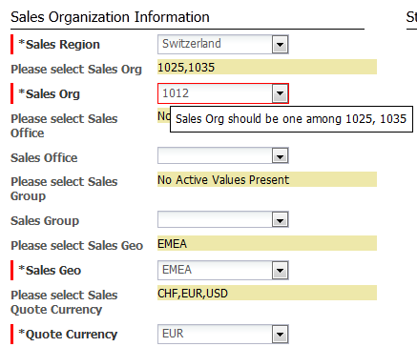

Sales Information for a Quote is Unique and will be selected by a User using the above attributes. Recommendations to the User will be given in the form of “Please select..” for each Sales Attribute based on the Attribute “Sales Region”.

Validation Rule is present on each Action for the above Sales Information as per the data table “**DataMgmtCountry**” .

## 2.2 Quote Category

### 2.2.1 Quote Category Flow

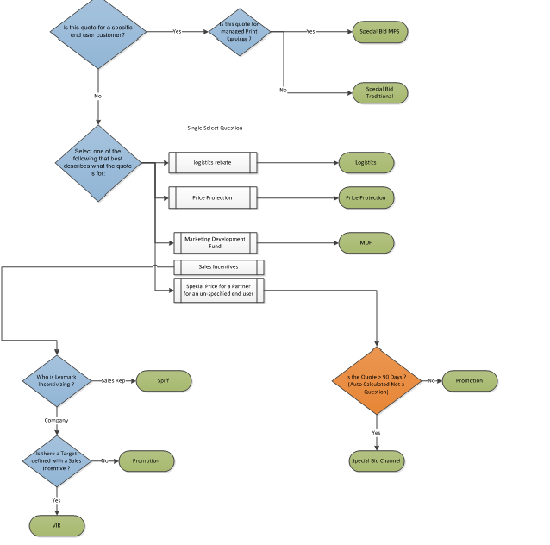

### 2.2.2 Quote Category Attributes in BM:

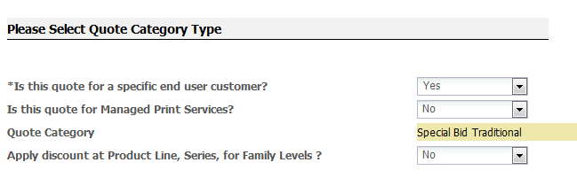

Based on the User’s Selection in the above attributes and based on the above flow, Quote Category will be populated on Auto-Update of dependent attributes.(they are shown in the blue color in the above flow.)

## 2.3 Pricing & Cals

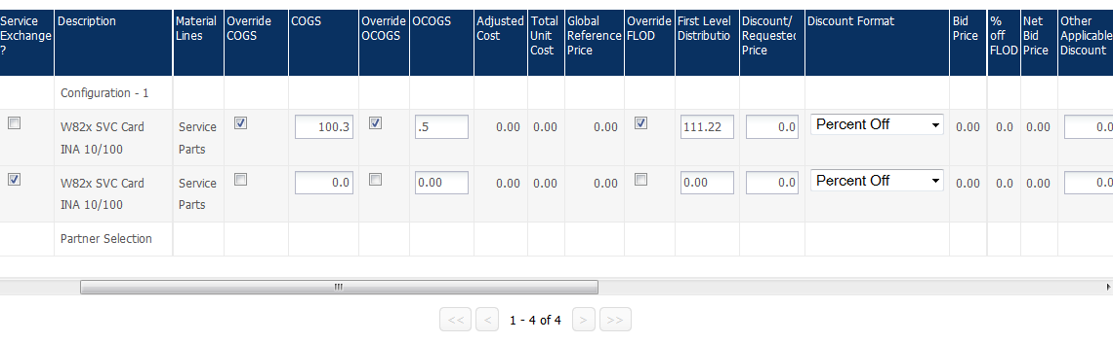

### 2.3.1 Datatable Lookups

**FLOD AND MSRP** 🡪Populated from “ReferencePriceTable” table based on the Columns [ConditionCurrency, Material, SalesOrganization, SalesOffice, SalesGroup] with the Attribute Values [Quote Currency, Part #,Sales Org, Sales Office, Sales Group]

**FLOD 🡪** *ConditionRate* [*ConditionType* = “ZLFD”]

**MSRP 🡪** *ConditionRate* [*ConditionType* = “ZFLR”]

**ExRateUSD_QC** 🡪 (ExRate from USD to QuoteCurrency based on the DataTable)

**COGS** 🡪Populated from “SupportingCostTable” table based on the Columns [Material, SalesOrganization] with the Attribute Values [Part #,Sales Org]

**COGS** **🡪** *UnitPrice* * ExRateUSD_QC

**OCOGS** 🡪Populated from “DataManagement_OCOGS” table based on the Columns [Geo] with the Attribute Values [SalesGeo]

**OCOGS** **🡪** *OCOGS* * ExRateUSD_QC

**When Service Exchange is selected for a Part[Service Exchange ? in the Line Grid]**

**FLOD,MSRP,COGS,OCOGS** 🡪Populated from “**ServiceParts_Price**” table based on the Columns [ *Material, SalesOrganization, SalesOffice, SalesGroup*] with the Attribute Values [Part #,Sales Org, Sales Office, Sales Group]

**FLOD 🡪** *ConditionRate* [*ConditionType* = “ZLFD”] * ExRateUSD_QC

**MSRP 🡪** *ConditionRate* [*ConditionType* = “ZFLR”] * ExRateUSD_QC

**COGS** **🡪** *ExchangeCost*\* ExRateUSD_QC * ExRateUSD_QC

**OCOGS** **🡪** *OCOGS* * ExRateUSD_QC * ExRateUSD_QC

**MonthlyMonoPageVolume,MonthlyColorPageVolume** 🡪Populated from “**PageData**” table based on the Columns [*MDM_ID, Geography*] with the Attribute Values [Part Custom Field 18,Sales Geo]

**MonthlyMonoPageVolume 🡪** *ProductUserPageMon* [*Printing_Type*= “Black”]

**MonthlyColorPageVolume 🡪** *ProductUserPageMon* [*Printing_Type*= “Color”]

[**Ship With Color**](https://devlexmark.bigmachines.com/admin/commerce/attributes/edit_attribute.jsp?id=21144580)**,** [**Ship With Mono**](https://devlexmark.bigmachines.com/admin/commerce/attributes/edit_attribute.jsp?id=21145076)🡪Populated from “**SWE**” table based on the Columns [*MDM_ID*] with the Attribute Values [Part Custom Field 18]

[**Ship With Mono**](https://devlexmark.bigmachines.com/admin/commerce/attributes/edit_attribute.jsp?id=21145076) **🡪** *Mono*

**Ship With Color 🡪** *Color*

### 2.3.2 Part Calculations

**Bid Price** = FLOD – Discount

**% off FLOD** = (FLOD- Bid Price) / FLOD) * 100

**Printers Lease Payment** = Bid Price * Lease rate [Calculated only for Printer]

**Monthly Payment** = Bid Price / Quote Term (in months) [Excluded for Printers & Supplies]

**Mono CPP** = Bid Price / Standard Yield

**Color CPP** = Bid Price / Standard Yield

**Bid Gross Margin $** = Bid Price – Total Unit Cost

**US$ Converted FLOD Price** = Bid Price * Exchange Rate of Currency

**Bid Margin %** = (Bid Price –Total Unit Cost) / Bid Price

**Net Bid Price** = Bid Price * Quantity

**Rebate** = FLOD- Bid Price

**exChRate_UnitPrice** = Exchange rate of Session currency compared to USD on date of quote creation

**Total Unit Cost** = COGS + OCOGS

**Ceiling Price** = ((Bid Price / 0.96)/0.92) –> [calculated only for Canadian Printers only]

### 2.3.3 Model Calculations

**∑ SUM OF EACH PART**

Group Printers Total Revenue = **∑ (Printer)** (Bid Price * Qty)

Group Cost Per Page= **∑ (Cost per Page)** + (MonoCPP + ColorCPP)

Group Printers Total Qty= **∑ (Printer Total Quantity)** + Qty

Group Printers Total Cost= **∑ (Printer Total Cost)** + (Total Unit Cost * Qty)

Group Printers Total FLOD = **∑ (Printer Total Flod)** + (fLODPrice * Qty)

Group Printers Total Discount= **∑ (Printer Total Discount)** + (Rebate * Qty)

Group Printers Total Bid Price= **∑ (Printer Total Bid Price)** + (Bid Price * Qty)

Group Printers Total Bid Margin $= **∑ (Printer Total Bid Margin $)** + (Bid Gross Margin $ * Qty)

Total Printers GP = Group Printers Total Revenue - Group Total HW Unit Cost

Group Printers Total Bid Margin %= (Total Printers GP /Group Printers Total Revenue)*100

Group Gross Margin $= Group Total Revenue - Group Total Cost

Group Gross Margin %= (Group Gross Margin $ / Group Total Revenue)*100

Group Options Total Revenue = **∑ (Options)** + (Bid Price * Qty)

Group Options Total Qty= **∑ (Options Total Quantity)** + Qty

Group Options Total Cost= **∑ (Options Total Cost)** + (Total Unit Cost * Qty)

Group Options Total FLOD = **∑ (Options Total Flod)** + (fLODPrice * Qty)

Group Options Total Discount= **∑ (Options Total Discount)** + (Rebate * Qty)

Group Options Total Bid Price= **∑ (Options Total Bid Price)** + (Bid Price * Qty)

Group Options Total Bid Margin $= **∑ (Options Total Bid Margin $)** + (Bid Gross Margin $ * Qty)

Total Options GP = Group Options Total Revenue - Group Total Options Cost

Group Options Total Bid Margin %= (Total Options GP /Group Options Total Revenue)*100

Group Supplies Total Revenue = **∑ (Supplies)** + (Bid Price * Qty)

Group Supplies Total Qty= **∑ (Supplies Total Quantity)** + Qty

Group Supplies Total Cost=**∑ (Supplies Total Cost)** + (Total Unit Cost * Qty)

Group Supplies Total FLOD = **∑ (Supplies Total Flod)** + (fLODPrice * Qty)

Group Supplies Total Discount= **∑ (Supplies Total Discount)** + (Rebate * Qty)

Group Supplies Total Bid Price= **∑ (Supplies Total Bid Price)** + (Bid Price * Qty)

Group Supplies Total Bid Margin $= **∑ (Supplies Total Bid Margin $)** + (Bid Gross Margin $ * Qty)

Total Supplies GP = Group Supplies Total Revenue - Group Total Supplies Cost

Group Supplies Total Bid Margin %= (Total Supplies GP /Group Supplies Total Revenue)*100

Group Warranty Total Revenue = **∑ (Warranty)** + (Bid Price * Qty)

Group Warranty Total Qty= **∑ (Warranty Total Quantity)** + Qty

Group Warranty Total Cost= **∑ (Warranty Total Cost)** + (Total Unit Cost * Qty)

Group Warranty Total FLOD = **∑ (Warranty Total Flod)** + (fLODPrice * Qty)

Group Warranty Total Discount= **∑ (Warranty Total Discount)** + (Rebate * Qty)

Group Warranty Total Bid Price= **∑ (Warranty Total Bid Price)** + (Bid Price * Qty)

Group Warranty Total Bid Margin $= **∑ (Warranty s Total Bid Margin $)** + (Bid Gross Margin $ * Qty)

Total Warranty GP = Group Warranty Total Revenue - Group Total Warranty Cost

Group Warranty Total Bid Margin %= (Total Warranty GP /Group Warranty Total Revenue)*100

Group Services Total Revenue = **∑ (Services)** + (Bid Price * Qty)

Group Services Total Qty= **∑ (Services Total Quantity)** + Qty

Group Services Total Cost= **∑ (Services Total Cost)** + (Total Unit Cost * Qty)

Group Services Total FLOD = **∑ (Services Total Flod)** + (fLODPrice * Qty)

Group Services Total Discount= **∑ (Services Total Discount)** + (Rebate * Qty)

Group Services Total Bid Price= **∑ (Services Total Bid Price)** + (Bid Price * Qty)

Group Services Total Bid Margin $= **∑ (Services Total Bid Margin $)** + (Bid Gross Margin $ * Qty)

Total Services GP = Group Services Total Revenue - Group Total Services Cost

Group Services Total Bid Margin %= (Total Services GP /Group Services Total Revenue)*100

Group Software Total Revenue = **∑ (Software)** + (Bid Price * Qty)

Group Software Total Qty= **∑ (Software Total Quantity)** + Qty

Group Software Total Cost= **∑ (Software Total Cost)** + (Total Unit Cost * Qty)

Group Software Total FLOD = **∑ (Software Total Flod)** + (fLODPrice * Qty)

Group Software Total Discount= **∑ (Software Total Discount)** + (Rebate * Qty)

Group Software Total Bid Price= **∑ (Software Total Bid Price)** + (Bid Price * Qty)

Group Software Total Bid Margin $= **∑ (Software Total Bid Margin $)** + (Bid Gross Margin $ * Qty)

Total Software GP = Group Software Total Revenue - Group Total Software Cost

Group Software Total Bid Margin %= (Total Software GP /Group Software Total Revenue)*100

Group Others Total Revenue = **∑ (Others)** + (Bid Price * Qty)

Group Others Total Qty= **∑ (Others Total Quantity)** + Qty

Group Others Total Cost= **∑ (Others Total Cost)** + (Total Unit Cost * Qty)

Group Others Total FLOD = **∑ (Others Total Flod)** + (fLODPrice * Qty)

Group Others Total Discount= **∑ (Others Total Discount)** + (Rebate * Qty)

Group Others Total Bid Price= **∑ (Others Total Bid Price)** + (Bid Price * Qty)

Group Others Total Bid Margin $= **∑ (Others Total Bid Margin $)** + (Bid Gross Margin $ * Qty)

Total Others GP = Group Others Total Revenue - Group Total Others Cost

Group Others Total Bid Margin %= (Total Others GP /Group Others Total Revenue)*100

Group Total 3 Year GP= (Total Printers GP + (Non Printer GP Total/ Contract Term))*36.0Total Service Parts GP= Group Total Others Revenue - Group Total Others Unit Cost;

Group Printers CPP = Group Printers Total Revenue /(Group Total Mono Pages + Group Total Color Pages)

Group Warranty CPP = Group Warranty Total Revenue /(Group Total Mono Pages + Group Total Color Pages)

Group Services CPP = Group Services Total Revenue/(Group Total Mono Pages + Group Total Color Pages)

Group Supplies CPP = Group Supplies Total Revenue /(Group Total Mono Pages + Group Total Color Pages)

Group Inclusive CPP = Group Printers CPP+ Group Services CPP + Group Supplies CPPP + Group Warranty CPP

Group Total Revenue= Group Printers Total Revenue + Group Others Total Revenue + Group Software Total Revenue + Group Services Total Revenue + Group Warranty Total Revenue + Group Options Total Revenue + Group Supplies Total Revenue

Group Total Qty = Group Printers Total Qty + Group Others Total Qty + Group Software Total Qty + Group Services Total Qty + Group Warranty Total Qty + Group Options Total Qty + Group Supplies Total Qty

Group Total Cost = Group Printers Total Cost + Group Others Total Cost + Group Software Total Cost + Group Services Total Cost + Group Warranty Total Cost + Group Options Total Cost + Group Supplies Total Cost

Group Total FLOD = Group Printers Total FLOD + Group Others Total FLOD + Group Software Total FLOD + Group Services Total FLOD + Group Warranty Total FLOD + Group Options Total FLOD + Group Supplies Total FLOD

Group Total Discount = Group Printers Total Discount + Group Others Total Discount + Group Software Total Discount + Group Services Total Discount + Group Warranty Total Discount + Group Options Total Discount + Group Supplies Total Discount

Group Total Bid Price = Group Printers Total Bid Price + Group Others Total Bid Price + Group Software Total Bid Price + Group Services Total Bid Price + Group Warranty Total Bid Price + Group Options Total Bid Price + Group Supplies Total Bid Price

Group Total Bid margin $ = Group Printers Total Bid Margin $ + Group Others Total Bid Margin $ + Group Software Total Bid Margin $ + Group Services Total Bid Margin $ + Group Warranty Total Bid Margin $ + Group Options Total Bid Margin $ + Group Supplies Total Bid Margin $

Group Total Bid Margin % = Group Printers Total Bid Margin % + Group Others Total Bid Margin % + Group Software Total Bid Margin % + Group Services Total Bid Margin % + Group Warranty Total Bid Margin % + Group Options Total Bid Margin % + Group Supplies Total Bid Margin %

Group Gross Margin $ = Group Total Revenue - Group Total Cost

Group Gross Margin % = (Group Gross Margin Dollar/ Group Total Revenue)*100

### 2.3.4 Total Calculations

Total Printers Revenue = ∑ (Models) Bid Price * Quantity

Total Printers Cost = ∑ (Models) Total Unit Cost * Quantity

Total Printers Margin = Total Printers Revenue- Total Printers Cost

Total Printers Margin % = (Total Printers Margin/ Total Printers Revenue) * 100

Total Warranty Revenue = ∑ (Models) Bid Price * Quantity

Total Warranty Cost =∑ (Models) Total Unit Cost * Quantity

Total Warranty Margin = Total Warranty Revenue- Total Warranty Cost

Total Warranty Margin % = (Total Warranty Margin/ Total Warranty Revenue) * 100

Total Supplies Revenue = ∑ (Models) Bid Price * Quantity

Total Supplies Cost =∑ (Models) Total Unit Cost * Quantity

Total Supplies Margin = Total Supplies Revenue- Total Supplies Cost

Total Supplies Margin % = (Total Supplies Margin/ Total Supplies Revenue) * 100

Total Options Revenue = ∑ (Models) Bid Price * Quantity

Total Options Cost = ∑ (Models) Total Unit Cost * Quantity

Total Options Margin = Total Options Revenue- Total Options Cost

Total Options Margin % = (Total Options Margin/ Total Options Revenue) * 100

Total Services Revenue = ∑ (Models) Bid Price * Quantity

Total Services Cost = ∑ (Models) Total Unit Cost * Quantity

Total Services Margin = Total Services Revenue- Total Services Cost

Total Services Margin % = (Total Services Margin/ Total Services Revenue) * 100

Total Solution Software Revenue = ∑ (Models) Bid Price * Quantity

Total Solution Software Cost = ∑ (Models) Total Unit Cost * Quantity

Total Solution Software Margin = Total Solution Software Revenue- Total Solution Software Cost

Total Solution Software Margin % = (Total Solution Software Margin/ Total Solution Software Revenue) * 100

Total Service Parts Revenue = ∑ (Models) Bid Price * Quantity

Total Service Parts Cost = ∑ (Models) Total Unit Cost * Quantity

Total Service Parts Margin = Total Service Parts Revenue- Total Service Parts Cost

Total Service Parts Margin % = (Total Service Margin/ Total Service Revenue) * 100

Formula NPV (Total Printers Margin, (Total Supplies Margin/ Contract Term/12), Discount Rate/100, Contract Term/12)

Formula Quote NPV (Total Printers Margin, (Total Supplies Margin/ Contract Term/12), Discount Rate/100, Page Volume)

Input:

Total Printers Margin= -151.70

Total Supplies Margin= -1,306.62

Discount Rate = 10

Output:

Quote NPV= -1,339.54

One Year NPV = -1,339.54

Two Year NPV = -2419.39

Three Year NPV = -3401.07

Input:

Total Printers Margin= -18.33

Total Supplies Margin= 0.00

Discount Rate = 10

Output:

Quote NPV= 18.33

One Year NPV = 18.33

Two Year NPV = 18.33

Three Year NPV = 18.33

## 2.4 Page Calculations

**Recommended Quantity**

For Parts Whose Material Line Type is “**Supplies**”

i)**Color Printer and a Black Supply**

*ROUNDED UP VALUE((((((Monthly Mono Page Volume of the AssociatedPrinter + Monthly Color Page Volume of the AssociatedPrinter)\** Quote Term (in months)*) – SWE Mono Page Volume of the AssociatedPrinter)*QTY OF the AssociatedPrinter)/CALCULATED YIELD OF THE SUPPLY))*

*ii)* **Color Printer and a Color Supply**

*ROUNDED UP VALUE((((((Monthly Color Page Volume of the AssociatedPrinter)\** Quote Term (in months)*) – SWE Color Page Volume of the AssociatedPrinter)*QTY OF the AssociatedPrinter)/CALCULATED YIELD OF THE SUPPLY))*

*iii)* **Black Printer and a Black Supply**

*ROUNDED UP VALUE((((((Monthly Mono Page Volume of the AssociatedPrinter)\** Quote Term (in months)*) – SWE Mono Page Volume of the AssociatedPrinter)*QTY OF the AssociatedPrinter)/CALCULATED YIELD OF THE SUPPLY))*

*iv)* **Black Printer and a Color Supply**

*Quantity of Associated Printer*

For Parts Whose Material Line Type is other than “**Supplies**” and “**Printers**” is the Quantity of the Associated Printer for that Model.

**NPVs AND GPs**

Total GP Year 1 = = ∑ (Group GP Year 1 * Quantity of the Associated Printer of the Model)

Total GP Year 2 = ∑ (Group GP Year 2 * Quantity of the Associated Printer of the Model)

Total GP Year 3 = ∑ (Group GP Year 3 * Quantity of the Associated Printer of the Model)

Total GP Year 4 = ∑ (Group GP Year 4 * Quantity of the Associated Printer of the Model)

Total GP Year 5 = ∑ (Group GP Year 5 * Quantity of the Associated Printer of the Model)

Initial Load = Total Printers GP

Net Cash Flow Array = {Total GP Year 1};

**Total NPV Year 1** = NPVFormula[Initial Load,Net Cash Flow Array,Discount Rate/100,1]

Net Cash Flow Array = {Total GP Year 1, Total GP Year 2};

**Total NPV Year2** = NPVFormula[Initial Load,Net Cash Flow Array,Discount Rate/100,2]

Net Cash Flow Array = {Total GP Year 1, Total GP Year 2, Total GP Year 3};

**Total NPV Year 3** = NPVFormula[Initial Load,Net Cash Flow Array,Discount Rate/100,3]

Net Cash Flow Array = {Total GP Year 1, Total GP Year 2, Total GP Year 3, Total GP Year 4};

**Total NPV Year 4** = NPVFormula[Initial Load,Net Cash Flow Array,Discount Rate/100,4]

Net Cash Flow Array = {Total GP Year 1, Total GP Year 2, Total GP Year 3, Total GP Year 4, Total GP Year 5};

**Total NPV Year 5** = NPVFormula[Initial Load,Net Cash Flow Array,Discount Rate/100,5]

## 2.5 Party Tables

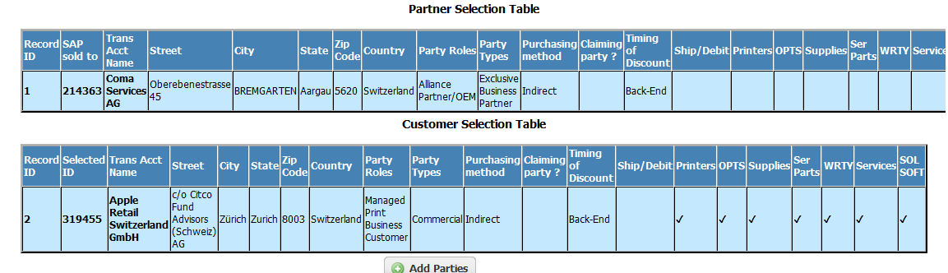

Partner and Customer Tables are populated from tabs “**Partner Selection**” and “**Customer End User Selection**” from the Model “Partner”.

User can click on Action “**Add Parties**” to add Parties to the Quote. There will be only one Partner Selection Model allowed per Quote.Users will be constrained on further clicks of “Add Parties”, when a Partner Selection Model is already present on the Quote.

## 2.6 Requestor History table

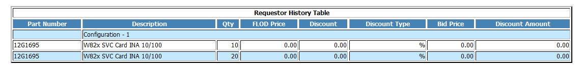

This is a HTML replica of the Line Item Grid with limited columns. This will only consist of the line data when Requestor has submitted the Quote for Approval. After Pending Step, though there will be changes on the Line Grid, it will not reflect.

This helps the User to compare the data before and after the Approval Process.

## 2.7 Summary P & L Table

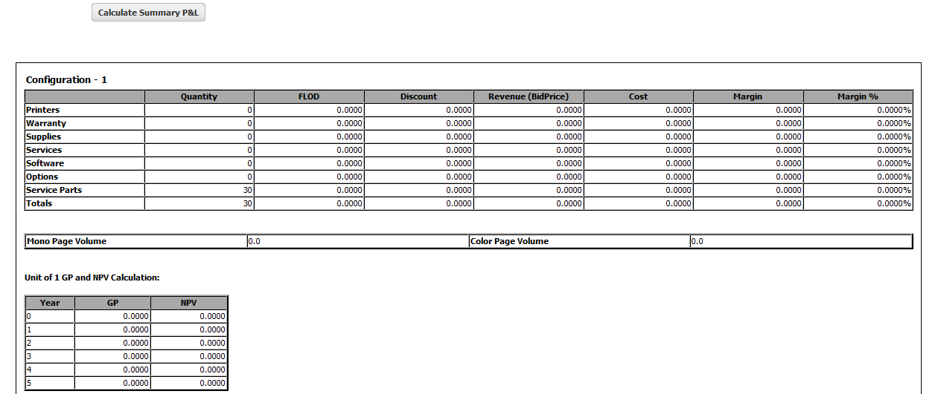

This table consists of the Model Level Attributes .The above three sets of table will be present for each Model. It displays the totals of the attributes for a Price attribute to each Material Line for a Model

The User has to click on the Action “**Calculate Summary P&L**” to see the updated Information.

## 2.8 Actions

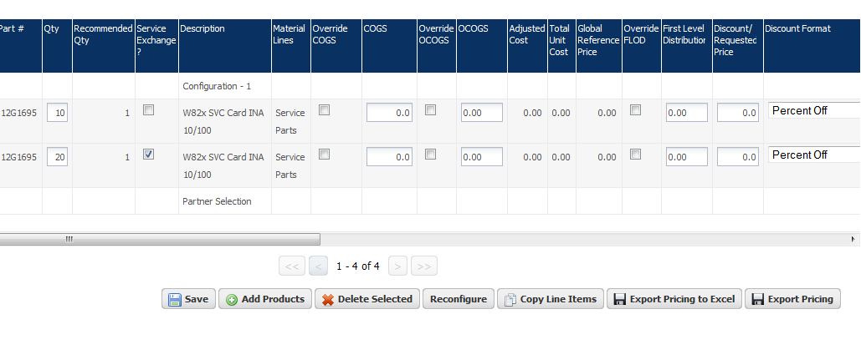

***Export Pricing to Excel 🡪*** This Action will be visible only for Approvers and Admin only. Users can click on this Action to view all the information on the Line Grid in an Excel

***Export Pricing 🡪*** This Action will be visible for Requestors. Users can click on this Action to view all the information that is viewed by a Requestor on the Line Grid in an Excel

***Save 🡪*** This Action will be used by the Users to Calculate Pricing.All the Price Attributes will be recalculated based on the changes done by the Users(like Discount, Discount Type, Quantity etc which are editable.)No data Table calls will be done in this Action

***Pull Current FLOD 🡪*** Users can click on this Action to update Data on the Quote from the DataTables.

***Add Products 🡪*** Users can click on this Action to add Models and Parts to the Quote

***ReConfigure 🡪*** Users can click on this Action to ReConfigure a existing model.

## 2.9 Master – Participant Quote

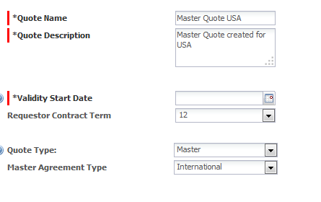

Users can create Master Quotes by selecting Quote Type as “Master” and Master Agreement Type as “International”.

When they click on Add Products, they will be navigated to Master Configurator

In Master Configurator, the User will choose Master Country, Currency and Participant Countries Info, Exchange Rates and Parts and their corresponding BidPrice.

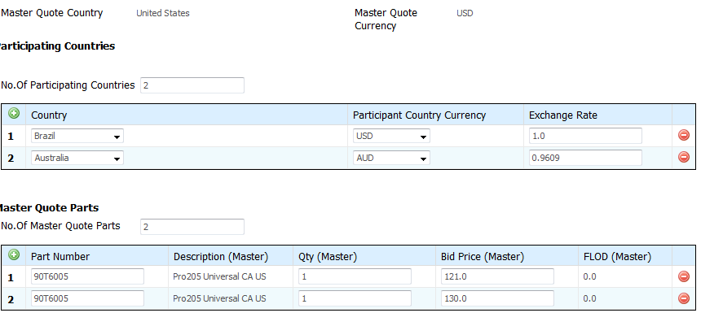

Master Country,Master Country Currency ,Participating Country Info will be populated in Master Quote and it will be not be changed once the first Model is added to the Quote.(Even through Reconfigure).

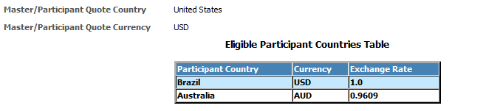

When a Master Quote is copied, it is converted to a Participant Quote. A Flag will be present at the top representing that the current Quote is a Participant of the Copied Master Quote as below.

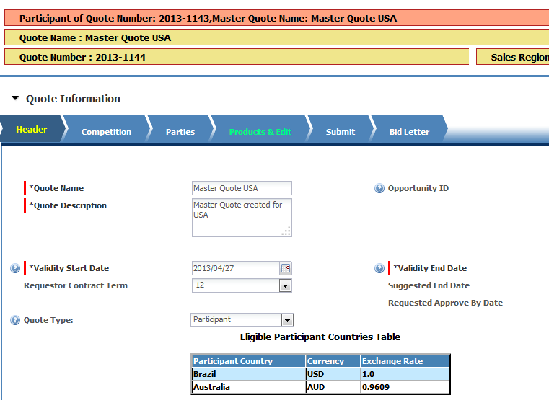

User is validated for selecting the Sales Information of the Quote as one of the Participant Countries Info present on the Quote

Users will select a Participating Country and Currency from the above list for a Participant Quote and clicks on Reconfigure on the Master Agreement Model.

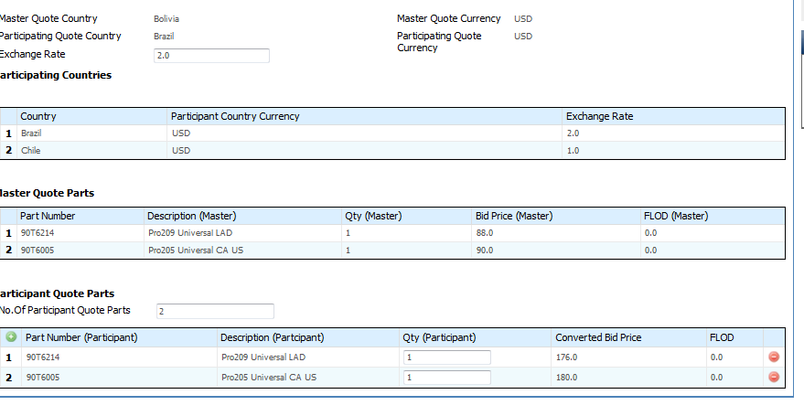

User clicks on Save and will navigate back to Commerce.

There will be an attribute called “Approved Master Bid Price in Local Currency” for the User to compare the Approved Master Bid Price in Master Quote to the BidPrice in the current Participant Quote as below.

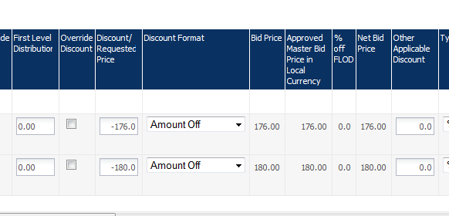

## 2.10 Constraint on Start and End Date

**User will be validated and has to follow the below rules:**

* Start Date cannot be after the End Date of the Quote
* When a Quote is copied and the reason is selected as “For Creating a New Quote ?”, Start Date cannot be before the Original Start Date of the Copied Quote.
* When a Participant Quote is created from a Master Quote through Copy, End Date of the current Participant Quote cannot be after the End Date of the copied Master Quote.

3. Approval Process

## 3.1 Approval tree Classification

Approval sequences have been defined based on quote category and the product line type.

Lexmark categorizes its quotes as follows -

1. Special bid MPS
2. Special bid non MPS
3. Promotions
4. MDF – Market development funds
5. VIR - Volume Incentive Rebates
6. LR – Logistics Rebates
7. PP - Price Protection

The second level of classification is based on Material Line of Products added to a quote. Possible values for Material line -

1. Printers
2. Supplies
3. Service parts
4. Warranty
5. Solutions Software

Approval levels are defined as follows -

* Sales Requestor Manager
* Quote Analyst
* Country
* Geo Pricing Analyst
* Geo Planning
* Geo Business
* Geo Pricing Director
* Worldwide

The above levels are different teams required to approve a particular quote, the sequence in which the approval steps should flow are highlighted in the following sections.

## 3.2 Reason Trees

### 3.2.1 Special Bid MPS

**Technical Details**

**Key Scenarios handled:**

* All quotes with Quote Category “**Special Bid MPS**”
* Flow differs for Quotes with ‘**Solutions Software**’ products (see Reason Mapping)
* Once a quote is rejected by an approver, it wil l be routed to the appropriate level of approval based on ‘Reject Reason’ flag set by the rejecting approver (see Reason Rejection)

**Fetching Approvers:**

* The approval nodes refer to ‘fetchUserGroupBasedOnGeo’ util function to fetch the approver groups and Primary Contact Person at every level
* The Approver Groups and Primary Contact Person login are stored in ‘ApprovalUserGroups’ data table – Based on the Quote Category and the level and Material line of the Products added to a quote, an approver is determined.

**Flow:**

Special Bid MPS handles two key flows for Special Bid MPS quote category – ISS and Special Bid MPS (see Approval Reason Matrix).

The reason tree involves a simple serial flow (no parallel approvers) with seven core levels and each level supporting an Ad hoc approver level.



### 3.2.2 Special Bid Channel

**Technical Details**

**Key Scenarios handled:**

* All quotes with Quote Category “**Special Bid Channel**”
* Flow differs based on the Material line of Products added to a quote
* Quotes with Supplies only follow the thresholds in ‘Channel Partner – Sup’ tab of Approval Reason Matrix
* Hardware Only Quotes – Non MPS – HW Only
* Hardware and Supplies – Non MPS – HW n Sup
* This reason tree also handles Service Parts(Trad, Channel, Pro - Serv Parts), Warranty (Trad, Channel, Prom – Warranty) and ISS (MPS, Trad, Channel, Prom - ISS)
* Once a quote is rejected by an approver, it will be routed to the appropriate level of approval based on ‘Reject Reason’ flag set by the rejecting approver (see Reason Rejection)

**Fetching Approvers:**

* The approval nodes refer to ‘fetchUserGroupBasedOnGeo’ util function to fetch the approver groups and Primary Contact Person at every level
* The Approver Groups and Primary Contact Person login are stored in ‘ApprovalUserGroups’ data table – Based on the Quote Category and the level and Material line of the Products added to a quote, an approver is determined.

**Flow:**

Special Bid Channel handles six different flows for Special Bid Channel quote category –Special Bid Channel Supplies Only, Warranty, Service Parts, Non MPS Hardware Only, Non MPS Hardware and Supplies and ISS (see Approval Reason Matrix)

The Reason tree has a serial flow till Geo Business level. After the quote is approved by Country and Geo Pricing Analyst, the request is routed to Geo Business Level based on the products added to a quote. Quotes with ‘Supplies’ that meet the threshold are routed to ‘**Geo Business Supplies**’ and quotes with ‘Solutions Software’ are routed to ‘**Geo Finance Directors**.’ These two approvers can choose to route the quote to Ad hoc approvers. Once the geo business level completely approves a quote, the request is then routed to ‘**Geo Pricing Director**.’ The flow merges here (achieved using isQuoteApprovedByAllLevels util) and from this point follows a serial approval.

‘**Geo Business Warranty**’ level is notified (see Watcher Profiles and Notifications for defining Notifications) when a quote is at Geo Business Level and has warranties and meets the thresholds whereas the ‘**Geo Business Parts**’ is not notified explicitly or is a part of the flow but receives a quote as an Ad hoc Approver (Geo Pricing Analyst routes a quote to the Geo Business Parts based on the products added to a quote)



### 3.2.3 Special Bid Traditional – HW Only

**Technical Details:**

**Key Scenarios handled:**

* Quotes with Quote Category “**Special Bid Traditional**” that have ‘**Printers**’ added as products to the quote
* Flow differs based on the Material line of Products added to a quote, Printers being a mandatory product
* Quotes with Hardware only follow the thresholds given in ‘Non MPS – HW Only’ tab of Approval Reason Matrix
* Hardware and Supplies – Non MPS – HW n Sup
* This reason tree also handles Service Parts(Trad, Channel, Pro - Serv Parts), Warranty (Trad, Channel, Prom – Warranty) and ISS (MPS, Trad, Channel, Prom - ISS)
* Once a quote is rejected by an approver, it will be routed to the appropriate level of approval based on ‘Reject Reason’ flag set by the rejecting approver (see Reason Rejection)

**Fetching Approvers:**

* The approval nodes refer to ‘fetchUserGroupBasedOnGeo’ util function to fetch the approver groups and Primary Contact Person at every level
* The Approver Groups and Primary Contact Person login are stored in ‘ApprovalUserGroups’ data table – Based on the Quote Category and the level and Material line of the Products added to a quote, an approver is determined.

**Flow:**

Special Bid Traditional HW Only tree handles five different flows for Special Bid Traditional quote category – Non MPS Hardware Only, Non MPS Hardware and Supplies, Warranty, Service Parts and ISS (see Approval Reason Matrix)

The flow is similar to that of Special Bid Channel – serial flow till Geo Pricing Analyst, Parallel approval flow at Geo Business level and merges at Geo Pricing Director level.



### 3.2.4 Special Bid Traditional – Supplies Only

**Technical Details**

**Key Scenarios handled:**

* Quotes with Quote Category “**Special Bid Traditional**” that do not have ‘**Printers**’ added as products to the quote
* Flow differs based on the Material line of Products added to a quote
* Quotes with Supplies follow the thresholds listed in ‘Non MPS – Sup, Win back’ or ‘Non MPS – Sup, non Win back’ depending on the value entered in ‘Win back.’
* This reason tree also handles Service Parts(Trad, Channel, Pro - Serv Parts), Warranty (Trad, Channel, Prom – Warranty) and ISS (MPS, Trad, Channel, Prom - ISS)
* Once a quote is rejected by an approver, it will be routed to the appropriate level of approval based on ‘Reject Reason’ flag set by the rejecting approver (see Reason Rejection)

**Fetching Approvers:**

* The approval nodes refer to ‘fetchUserGroupBasedOnGeo’ util function to fetch the approver groups and Primary Contact Person at every level
* The Approver Groups and Primary Contact Person login are stored in ‘ApprovalUserGroups’ data table – Based on the Quote Category and the level and Material line of the Products added to a quote, an approver is determined.

**Flow:**

Special Bid Traditional Supplies Only handles five different flows for Special Bid Traditional quote category – Non MPS – Supplies Win back, Non MPS – Supplies Non Win back, Warranty, Service Parts and ISS (see Approval Reason Matrix)

The flow is similar to that of Special Bid Channel – serial flow till Geo Pricing Analyst, Parallel approval flow at Geo Business level and merges at Geo Pricing Director level. This reason tree covers all the combinations of Products without Printers (For ex – Supplies Only, Warranty Only, Parts Only, Supplies and Warranty, Supplies, Warranty and ISS etc.,)



### 3.2.5 Promotions – Hw and Supplies

**Key Scenarios handled:**

* All quotes with Quote Categories “**Promotion**” or “**Spiff**”
* Flow differs based on the Material line of Products added to a quote
* Quotes with Hardware or Supplies follow the thresholds mentioned in ‘Promotion – HW n Sup’ tab of Approval Reason Matrix
* This reason tree also handles Service Parts(Trad, Channel, Pro - Serv Parts), Warranty (Trad, Channel, Prom – Warranty) and ISS (MPS, Trad, Channel, Prom - ISS)
* Once a quote is rejected by an approver, it will be routed to the appropriate level of approval based on ‘Reject Reason’ flag set by the rejecting approver (see Reason Rejection)

**Fetching Approvers:**

* The approval nodes refer to ‘fetchUserGroupBasedOnGeo’ util function to fetch the approver groups and Primary Contact Person at every level
* The Approver Groups and Primary Contact Person login are stored in ‘ApprovalUserGroups’ data table – Based on the Quote Category and the level and Material line of the Products added to a quote, an approver is determined.

**Flow:**

Promotion reason tree handles four different flows for Promotion and Spiff quote categories –Promotion Hardware or Supplies, Warranty, Service Parts and ISS (see Approval Reason Matrix)

The flow is similar to that of Special Bid Channel – serial flow till Geo Pricing Analyst, Parallel approval flow at Geo Business level and merges at Geo Pricing Director level.



### 3.2.6 MDF, VIR, LR and Price Protection

**Key Scenarios handled:**

* All quotes with Quote Categories “**MDF**” or “**VIR**” or “**Logistics**” or “**Price Protection**”
* The order of approvers in this case is same irrespective of the Material line of the Products added to the quote
* All quotes follow the thresholds listed in ‘MDF, VIR, LR, Price Prot’ tab of Approval Reason Matrix
* Once a quote is rejected by an approver, it will be routed to the appropriate level of approval based on ‘Reject Reason’ flag set by the rejecting approver (see Reason Rejection)

**Fetching Approvers:**

* The approval nodes refer to ‘fetchUserGroupBasedOnGeo’ util function to fetch the approver groups and Primary Contact Person at every level
* The Approver Groups and Primary Contact Person login are stored in ‘ApprovalUserGroups’ data table – Based on the Quote Category and the level and Material line of the Products added to a quote, an approver is determined.

**Flow:**

This reason tree has a simple serial flow and handles Approval for four different quote categories – it goes through three core approver levels each supporting an ad hoc approver level

Irrespective of the line items added to the quote – the flow remains the same – Country, Geo Planning and World Wide.



### 3.2.7 Quote Analyst

**Key Scenarios handled:**

* All quotes that meet thresholds such that they require a review from the Quote Analyst (see Quote Analyst tab in Reason Matrix)
* The Quote Analyst reason tree is an additional approval flow that runs in parallel with the one of the Core approval flows (3.1 to 3.6)
* If a quote meets the thresholds for Quote Analyst, along with its core approval flow (based on the quote category), this approval is triggered simultaneously. If triggered, the Quote Analyst’s approval is mandatory for the quote to be completely Approved

**Fetching Approvers:**

* The approval nodes refer to ‘fetchUserGroupBasedOnGeo’ util function to fetch the approver groups and Primary Contact Person at every level
* The Approver Groups and Primary Contact Person login are stored in ‘ApprovalUserGroups’ data table – Based on the Quote Category and the level and Material line of the Products added to a quote, an approver is determined.

**Flow:**

This reason tree has a simple two level approval flow – first being the reason check and the immediate node is the Quote Analyst approver level.



### 3.2.8 Approval Reason Matrix

Following are the conditions at each approver level and for every Quote Category – Product combination. All the conditions work independently (logically combined with OR)

Credit (Notification only) and Legal (Notification only) tab list the conditions which when met by a quote, the corresponding teams will be notified with ‘Watcher Notifications (see Watcher Profiles and Notifications)



### 3.2.9 How Do They Work Together?

Here is how a quote is routed to Approvers and how the step transitions work –

* Once a quote is created (or copied or imported as a legacy quote), it remains in the **Start** step till it is saved.
* Any modify action updates the step of the quote to ‘**Pending.**’
* If a user clicks on ‘Submit for Approval’ action, the system evaluates all the reason trees to check if the quote meets thresholds in any of the Approver nodes. If there is at least one reason node that the quote satisfies, ‘**Request for Approval**’ action is invoked else ‘**Submit for Approval**’ is invoked.
* Submit action moves the quote from ‘Pending’ or ‘Start’ to ‘**Submitted for Approval**’ step.
* To fetch the approvers, at each node ‘fetchUserGroupBasedOnGeo’ is utilized. This method fetches the Approver Groups names and Primary Contact Person name from an internal attribute ‘Approval User Groups (Internal Attribute)’ – this value is populated in the Pricing function when user adds new products to a quote or reconfigures existing configurations
* The above util returns the Approver string in the desired format.

1~userLogin~companyName|2~groupName~companyName|

* While parsing the string, if the util encounters Country and Geo groups, it refers ‘UserInfoTable’ to route the approval request to a user based on the ‘Sales Region’ and ‘Sales Geo’ of the quote respectively. For Country level, only the users who belong to the Sales Region of the quote receive a request and for Geo levels (Geo Pricing Analyst, Geo Pricing Director, Geo Business and Geo Planning), users who belong to the Sales Geo of the quote receive a request for approval
* The Approval Selection works as mentioned above for all the approval nodes. The Approval condition has logic for evaluating reasons given in ‘Approval Reason Matrix.’
* Approve and Reject actions have advanced validation – Approve action requests the user to enter a value for ‘Approval Reason’ and Reject ‘Reject Reason.’ Approval Reason attributes helps us the requestor know which Approver has updated a quote. **Reject Reason** is the key driver for Rejection scenarios developed – it helps the approval flow to resume at the level where it was rejected (see Reason Rejection).
* Once all the levels approve a quote, ‘Submit for Approval’ action is invoked. This moves the quote to ‘**Approved**’ step

## 3.3 Watchers and Approvers

Lexmark supports profiles with user groups that need to be notified when a quote is submitted or reaches a level in the approval flow. These profiles are termed ‘Watcher’ profiles. These users are notified via email when the quotes meet the threshold (see Approval Reason Matrix notification only tabs)

**Notifications on Submission** –

The following users are notified when a quote is submitted for approval –

* Requestor’s manager
* Geo Credit Management Team (if quote meets the threshold)
* Geo Legal and Contract Team (if quote meets the threshold)

***Technical Solution***: When a user clicks on Submit for Approval, Request for Approval action is invoked which calls ‘fetchApproverEmailIds’ util method. This method populates ‘Approver Email Ids (Internal Attribute) with the email ids of Requestor’s manager and Geo Credit and Legal teams if the quote meets thresholds. The email ids are obtained from User Info table.

To send out email notifications ‘Define Notifications’ option is utilized on the transition rule for ‘Request Approval’ in Start and Pending steps. As and when this step transition executes, a notification is sent out to the email ids populated in the above attribute.

**Geo Business Notifications** –

When a quote reaches the Geo Business level, depending on the products added and Sales Geo of the quote, certain users are notified. Following are the groups that are notified –

* Geo Business Warranty
* Geo Business Parts

***Technical Solution***: The email ids for users in above user groups are populated in Geo Business Notifications attribute by ‘fetchApproverEmailIds’ util as mentioned in the previous sections. However, these notifications are sent out only after the quote has been approved by ‘**Geo Pricing Analysts**’ and is at the Geo Business level. As the notifications have to be fired when the quote is still under review (or in Submitted for Approval step), there is no specific transition rule for this scenario.

To achieve this, for Approver profile, a self-transition has been added for ‘Submitted for Approval’ step and notifications have been defined to send out emails to the ids in ‘Geo Business Notifications’ attribute only after the quote has been approved by Geo Pricing level (Approval Status attribute check)

## 3.4 Adhoc Approvers

Often, a quote might require approval from a user who might not be a part of Approver profile or a part of the flow. In such cases an Approvers can route their quotes to appropriate users using ‘Ad hoc Approver’ functionality.

Every approver before approving a quote can wish to enter a valid login in the system to which the Approval Request can be routed to. This is achieved by adding an optional approval node after every core approval node in all the flows.

When a quote is under review, a text attribute ‘Add Approver’ is available for all the core approvers. Before approving the quote, the user should enter a valid user login (available in the instance) and click ‘Approve.’

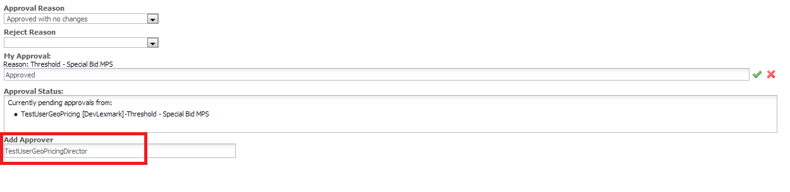

The text attribute accepts both logins and email ids – ‘getUserDetails’ util is referenced in all the optional approver nodes to fetch the approver string from user input. If the login entered in the text box is invalid, the system throws the following error –

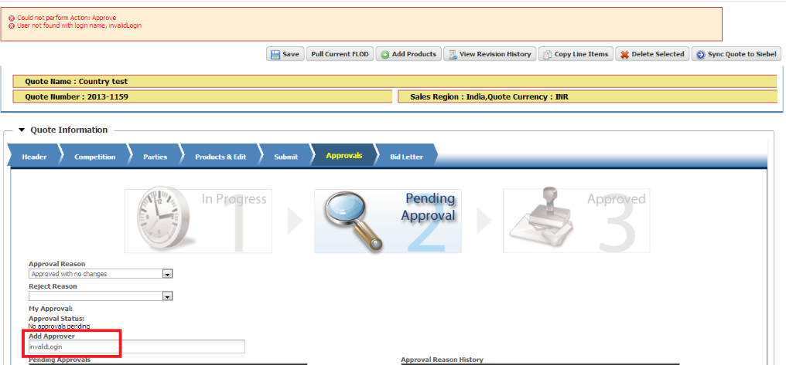

The logic in the approver nodes ensures that these optional approval nodes are executed only when the corresponding ‘Add Approver’ attributes is not blank. Eight optional ‘Add Approver’ attributes have been created for this purpose. Depending on the current logged in user’s groups, only the required attribute is displayed and the rest are hidden from the view.

Routing a quote to an Ad hoc Approver –



Hiding Rules –

|  |  |
| --- | --- |
| **Name** | **Description** |
| Hide Optional Approvers at Sales Mngmt | Rule to hide Ad hoc Approver attributes for Requestor's Manager |
| Hide Opt Approvers for Sales MPS Operations | Rule to hide Ad hoc Approver attributes for Sales MPS Operations |
| Hide Opt Approvers at Country Level | Rule to hide Ad hoc Approver attributes for Country Approvers |
| Hide Opt Approvers at Geo Pricer level | Rule to hide Ad hoc Approver attributes for Geo Pricing Analysts |
| Hide Opt Approvers at Geo Business Supplies | Rule to hide Ad hoc Approver attributes for Geo Business Supplies |
| Hide Opt Approvers at Regional Finance Director | Rule to hide Ad hoc Approver attributes for Geo Finance Directors |
| Hide Opt Approvers at Geo Pricing Director | Rule to hide Ad hoc Approver attributes for Geo Pricing Directors |
| Hide Opt Approvers at WorldWide | Rule to hide Ad hoc Approver attributes for World Wide Approvers |
| Hide Opt Approvers for Quote Analyst | Rule to hide Ad hoc Approver attributes for Quote Analysts |

## 3.5 Approval Related Attributes

All the conditions/thresholds in Approval nodes use only quote level attributes. Following are the list of attributes used –



## 3.6 Reason Rejection

Lexmark approval flow supports two key rejection scenarios – **Rejection to Requestor** and **Rejection to an Approver Level.**

**Rejection to Requestor** –

This is the basic rejection scenario that gives access to the Requestor after rejection so that he can revise his quote and resubmit it.

**Rejection to an Approver level** –

Alternatively, an approver can choose to reject a quote to any approver level. For this rejection, the quote should not go to the requestor but should be reverted to the approver in the flow.

***Technical Solution***: An advanced validation rule is triggered on ‘Reject’ action that requests an approver to enter a value for ‘**Reject Reason**’ attribute. Value entered in this attribute is the key driver for both the rejection scenarios mentioned above.

Two different step transition rules have been set up in Submitted for Approval step for ‘Reject’ action. The first transition rule handles the first scenario – it moves the quote to ‘Pending’ step so that the Requestor gains complete access of the quote. This transition rule fires only when Reject Reason is ‘**Reject to Requestor**.’ For all other rejections, the second transition rule is triggered – which is a simple self-transition.

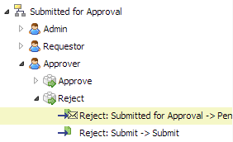

For rejection to an approver level, the quote has to be routed to an approver level in the tree, skipping all the previous levels. To achieve this two timers have been set up. Following is the detailed flow -

* Advanced Modification on ‘Reject’ action updates two attributes when Reject Reason is any value other than ‘Reject to Requestor.’

1. Auto Revise (Boolean flag)
2. Rejection Time (Date time attribute)

* On self-transition for Rejection to an approver level, the quote still remains in the ‘Submitted for Approval’ step.
* ‘**Auto Revise**’ timer of Submitted for Approval step is triggered (only if the Auto Revise flag is set) one minute after Reject as shown below -

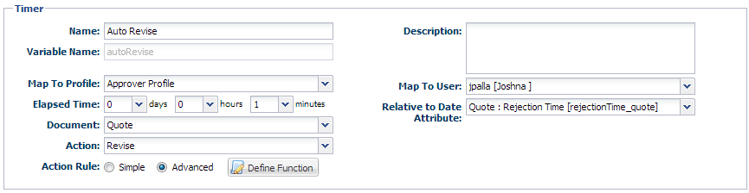

* The timer triggers Revise action. Revise action under Submitted for Approval step has two different transition rules – one for Rejection to Requestor and the other for Rejection to approver levels –

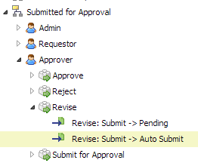

* The first transition rule is to handle the normal ‘Revise’ scenarios – that moves the quote to Pending step whereas the second transition is specific to the Auto Revise timer. This rule moves the quote to a temporary internal step – ‘**Auto Submit Step**’
* Advanced Modification on ‘Revise’ in turn updates two attributes when Reject Reason is any value other than ‘Reject to Requestor.’

1. Auto Submit (Boolean flag)
2. Revision Time (Date time attribute)

* The Auto Revise flag is reset to ‘false’ to ensure the Timer is not triggered recursively
* ‘Auto Submit’ timer in Auto Submit step is triggered (only if the Auto Submit flag is set) one minute after Revise as shown below –

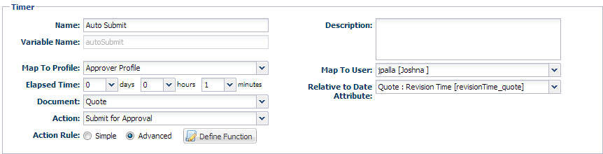

* The above timer resubmits the quote. The approval thresholds at every level ensure that the quote resumes at the level to which the quote was rejected. (Each approver node has a Reject Reason check along with the thresholds from Approval Reason Matrix)
* This flow ensures that the quote does not go back to the requestor and is sent to the Approver instead.

## 3.7 Pending Approvers and Approval History

**Pending Approvals** –

A customized HTML table built to display the Approver levels that need to approve a quote. The levels are determined by evaluating each threshold. ‘getApproverList’ Commerce library and ‘pendingApprovalsHTMLTable’ functions hold the logic for displaying it.

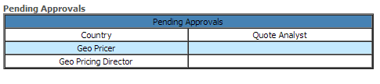

**Approval and Rejection History** –

The standard Approval history attribute that Big Machines provides is reset every time a quote is revised. To have the same functionality and avoid reset of history, Approval and Rejection History HTML table was built. Below is a sample table. ‘populateApprovalHistory’ and ‘populatePendingApprovals’ util functions use the standard Approval History attribute (approval_history_submit_quote) to consolidate the history.

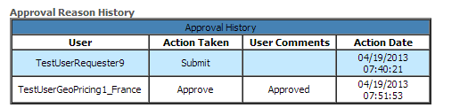

## 3.8 Util Libraries

### 3.8.1 Populate Approval Category

**Name:** populateApprovalCategory

**Description:** Util function to populate ‘Approval Reason Category’ attribute with the Material line of the parts added to a quote. Referenced in the Pricing function, accepts a string dictionary (Material line of the products) as parameter and populates the multi select menu attribute

### 3.8.2 Get User Details

**Name:** getUserDetails

**Description:** Returns an approver string in valid format based on value entered in an Ad hoc approver attribute. If the input is in an email id format, it fetches the login id and gives the desired approver string. Referenced in all Ad hoc approver nodes

### 3.8.3 Reset Optional Approvers

**Name:** resetOptionalApprovers

**Description:** Resets the ad hoc approver attributes once the quote has been by that level. It is invoked on Approve action.

### 3.8.4 Fetch User Group Based on Geo

**Name:** fetchUserGroupBasedOnGeo

**Description:** Util function to fetch approvers for an approver level. It is referenced in all the non-Ad hoc approver nodes. It returns a valid approver string based on the Approver level, Quote Category and Material lines of the Products added to the quote. Approval user group mapping is stored in Approval User Groups data table using which Approval User Groups (Internal attribute) is populated. Fetch User Groups method uses this attribute to avoid data table calls at each approver node. For Country and Geo approver levels, only the users who belong to the Sales Region and Sales Geo resp. are queried for (from User Info table) and returned. All other approver levels have a user Groups and a Primary Contact Person (optional) as approvers.

### 3.8.5 Populate Approval History

**Name:** populateApprovalHistory

**Description:** Util function to populate Approval History strings with Approver comments. Uses standard ‘Approval History Submit’ attribute for this purpose

### 3.8.6 Is Quote Approved By All Levels

**Name:** isQuoteApprovedByAllLevels

**Description:** Util function that determines if a quote has been approved by all the Geo Business approvers and their immediate Ad hoc approvers (if any). This logic helps in merging the parallel approvals at Geo Pricing Director level

### 3.8.7 Populate Approval Status On Quote

**Name:** populateApprovalStatusOnQuote

**Description:** Populates ‘Approval Status’ attribute on Approve action based on the current logged in user group

### 3.8.8 Reset Quote Approval Status

**Name:** resetQuoteApprovalStatus

**Description:** Resets the Approval Status attribute when a quote is rejected. Approval Status gives information on the levels that have already approved a quote. On rejection to an approver level, this method ensures that the value of Approval Status is rolled back to the level to which it was rejected.

### 3.8.9 Populate Pending Approvals

**Name:** populatePendingApprovals

**Description:** Util to populate Approval and Rejection history internal attribute with the login of the Approver, Approver’s group name, Company Name, Action take (Approve, Reject or Submit), Time of Approval/Rejection and Approver Comments.

### 3.8.10 Pending Approvals HTML Table

**Name:** pendingApprovalsHTMLTable

**Description:** Populates the Pending Approvals HTML table with the values passed by getApproverList commerce library function.

### 3.8.11 Fetch Approver Email Ids

**Name:** fetchApproverEmailIds

**Description:** This util function is called when approval is requested for a quote. It populates Geo Business Notifications attribute, Country Approvers attribute and Approver Email ids (internal attribute) with the email ids of the approvers at the respective levels. These attributes are used to send out watcher notifications.

## 3.9 Commerce Libraries

### 3.9.1 Get Approver List

**Name:** getApproverList

**Description:** Holds logic to populate the Pending Approvals table. It evaluates all the thresholds and determines the Approver levels the quote has to go to for it to be completely approved.

### 3.9.2 Get Approver Groups ListFetch Approver Email Ids

**Name:** getApproverGroupsList

**Description:** Populates Current Approver Levels attribute (reporting string) with the Approver group names. On Approve action, the approved levels are eliminated from the string. At any point this attribute indicates the Approver groups from which a quote is still awaiting approval.

## 3.10 Data Tables

**Approval User Groups** –

**Name**: ApprovalUserGroups

**Purpose**: Stores Approver User Group to Quote Category and Product Line Item mapping. Used in the Pricing function to populate Approval User Groups (Internal attribute). This attribute is used in all core Approver Nodes to get the name of the group to which an approval request has to be routed to.

**User Info Table** –

**Name**: UserInfoTable

**Purpose**: Extract of Users in the site - Referenced in Approval nodes to fetch Sales Manager Id, required approvers for Country and Geo groups and also in fetchApproverEmailIds util to get the email ids of Watcher groups

## 3.11 Reporting Strings

Two commerce attributes are used for Reporting that are based on Approvers, Approval and Rejection history.

**Current Approval Levels** –

***Format of the data***: groupName|companyName[$$groupName|companyName ]

***Sample***: countryGM|Lexmark$$geoPricing|Lexmark

***Technical Details***: getApproverGroupsList library function populates ‘Current Approver Levels’ attribute with the levels that need to approve a quote before it is completely approved. The levels are updated every time Approve is invoked to hold only the groups that are yet to approve.

**Approval and Rejection History** -

***Format of the data***: userLogin|userGroup|companyName|action|userComments|time

***Sample***: TestRequestor1|salesRequester|Lexmark|Submit||05/02/2013 02:51:32$$TestUserSalesMPS|salesRegionMPSOperations|Lexmark|Approve|Approved|05/02/2013 02:53:50

***Technical Details***: ‘populateApprovalHistory’ and ‘populatePendingApprovals’ util functions populate the ‘Approval and Rejection History (Internal attribute). This attribute is also used to populate the Approval and Rejection History HTML table.

## 3.12 Email Notifications

**Pending Approvals Notification** –

This email notification is sent out to the Approvers requesting their approval for a quote. The template is defined in ‘Email Templates’ and used in the notification section of Approver nodes. Following is a sample Pending Approvals notification.

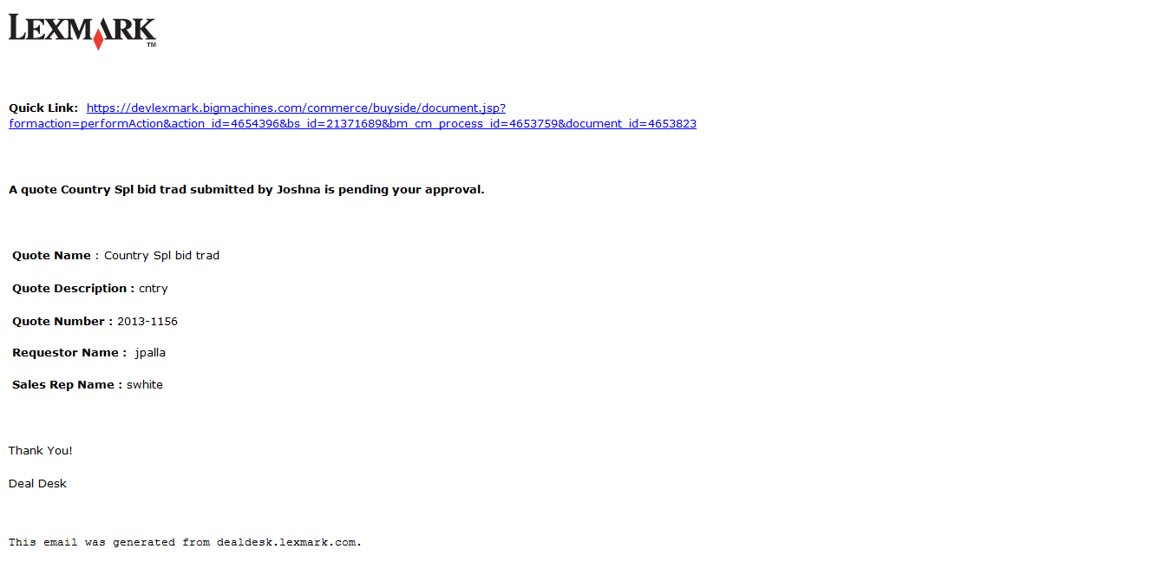

**Watcher Notification** –

The watcher notifications are sent out to Geo Business approvers and Sales Manager levels. These notifications are defined in the steps on ‘Approve’ and ‘Request for Approval’ actions resp.

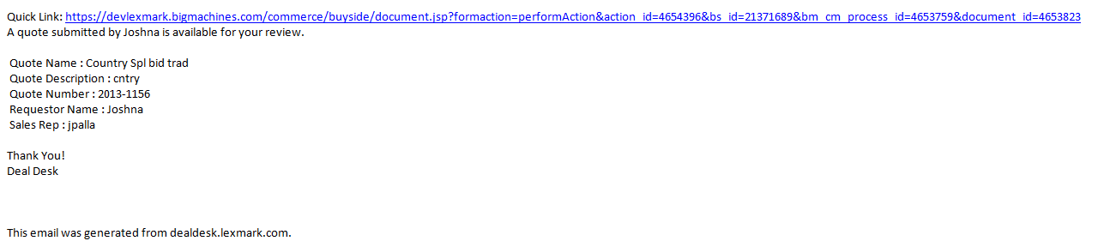

**Rejection Notification** –

A standard rejection email is sent out each time ‘Reject’ action is invoked. To handle the two rejection scenarios, an additional email (given below) is sent out on ‘Reject to Requestor.’ This notification is defined on transition rules for ‘Reject’ action.

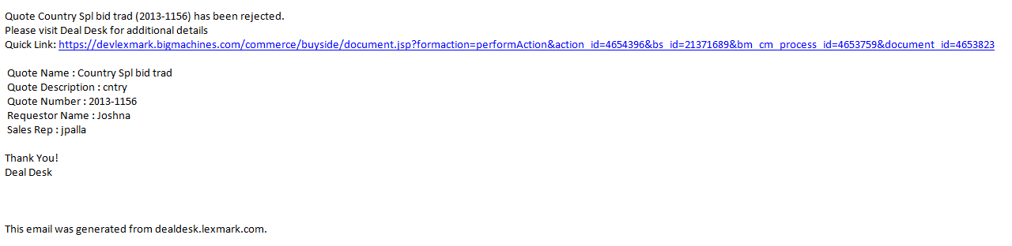

**Final Approval Notification** –

This is a system’s default email notification that is sent to a requestor when a quote is completely approved.

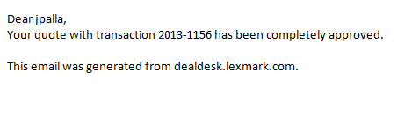

**Quote Finalized Notification** –

This email notification is sent to the Requestor of a quote and the Requestor manager when a quote is finalized. It is defined on step transition for ‘Finalize’ action.

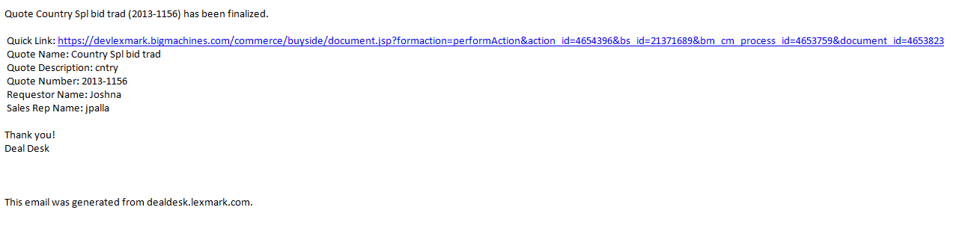

4. Security Controls

## 4.1 Participant Profiles

Lexmark categorizes its user groups into five participant profiles. Following are the participant profiles defined –

* Admin
* Approver
* Requestor
* View Only
* View Only w/o P&L

## User Groups

Each user group is mapped to a participant profile. Following is the User Group – Participant Profile mapping

|  |  |  |
| --- | --- | --- |
| **Group Label** | **Group Name** | **Participant Profile** |
| Admin group | adminGroup | Admin |
| CFO | pcCFO | View Only |
| Corporate Credit Manager | pcCorporateCreditManager | View Only |
| Corporate Treasure | pcCorporateTreasure | View Only |
| Country Sales Approver | countryGM | Approver |
| Country Watcher | countryWatcher | View Only |
| Credit Management Director | pcCreditManagementDirector | View Only |
| Geo Business Parts | geoBusinessParts | View Only |
| Geo Business Supplies | geoBusinessSupplies | Approver |
| Geo Business Warranty | geoBusinessWarranty | View Only |
| Geo Credit Management Team | pcCreditmanagementTeam | View Only |
| Geo Finance Director | geoFinanceDirector | Approver |
| Geo Legal and Contract Team | plLegalAndContractTeam | View Only |
| Geo Planning | geoPlanning | Approver |
| Geo President | geoPresident | View Only |
| Geo Pricing | geoPricing | Approver |
| GeoPricingDirector | geoPricingDirector | Approver |
| Quote Analyst | psQuoteAnalyst | Approver |
| Requestor | salesRequester | Requestor |
| Requestor Manager | salesRequesterManager | Requestor |
| Sales region MPS Operations | salesRegionMPSOperations | Approver |
| VP Finance | pcVPFinance | View Only |
| WW Pricing | wWPricing | Approver |

## 4.3 Steps

One additional step has been added to the existing six steps. ‘Auto Submit Step’ is to handle the Rejection scenario – it’s a temporary internal step in which timers have been defined to Auto Submit a quote that has been rejected to an approver level . Following are the steps –

* Start
* Pending
* Auto Submit Step
* Submitted for Approval
* Approved
* Finalized
* Trashed

## 4.4 User Access Rights

User access at each step is determined by Performer steps or User Groups added

### 4.4.1 Performer Steps

Performer steps have been used for ‘**Requestor**’ profile (as shown below) to ensure that quotes created by a Requestor are not visible to the other requestors.

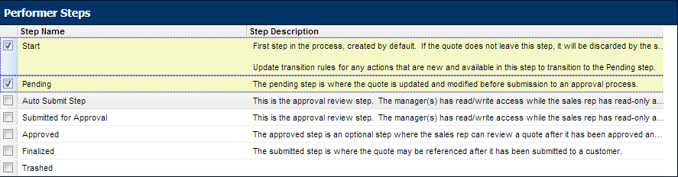

### 4.4.2 Groups

For Approver, Admin and View Only profiles, user groups are added to ‘User Access Rights.’ All the users in the selected quotes can view the quotes

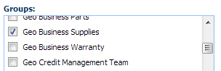

## 4.5 Auto Forwarding Rules

Unlike requestors (Performer steps) and Approvers (Groups), Sales Managers receive access to a quote when it is forwarded to them. Auto forwarding rules have been defined at each step to forward the quote to Requestor’s Sales Manager

|  |  |  |
| --- | --- | --- |
| Name | Description | Variable Name |
| CRM Partner URL | cRMPartnerURL | Text |
| CRM Partner Session Id | cRMPartnerSessionId | Text |
| Tier | serverPerformance | Text |
| Server Module | serverChassis | Text |
| Servers | servers_quantity | Integer |
| Blades | blades_quantity | Integer |
| Server Rack | racksEnclosures | Text |
| Processor | processors | Text |
| RAM | ram | Text |
| RAM Configuration | ramConfiguration | Text |
| Number of Processors | numberOfProcessors | Integer |
| Hard Drive | hardDrives | Text |
| Optical Drive | opticalDrive | Text |
| Power Supply | powerSupply | Text |
| Floppy Drive | slimFloppyDrive | Boolean |
| Additional HDD's | additionalHD | Boolean |
| HD Control [Array Control Attribute] | raidControl | Integer |
| Additional Hard Drive | hardDrive_raid_array | Text |
| Redundant Power Supply | redundantPowerSupply | Boolean |
| Cloud Storage | cloudStorage | Text |
| Cloud Backup | cloudBackup | Boolean |
| Volume Price Information | volumePriceInformation | HTML |
| OS Licenses | oSLicenses | Integer |
| Software Package | softwarePackage_array | Text |
| Application Counter [Array Control Attribute] | applicationSoftwareCounter | Integer |
| Licenses | licenses_array | Integer |
| Maintenance | maintenance_array | Text |
| Start Date | startDate_array | Date |
| End Date | endDate_array | Date |
| Qty | qty_array | Integer |
| Support Level | supportLevel | Text |
| Rebate | rebate | HTML |
| Monitoring | monitoring | Text |
| Services Requested | servicesRequested | Text |
| Modify Service Details | modifyServiceDetails | Boolean |
| Resource | service_servArray | Text |
| Service Detail | serviceDetail_servArray | Text |
| Resources | resources_servArray | Integer |
| Service Counter [Array Control Attribute] | serviceDetailController | Integer |
| Rate Level | rateLevel_servArray | Integer |
| Flex | flex_servArray | Text |
| Price | price_servArray | Currency |
| Hours | hours_servArray | Integer |
| Server | server_advArray | Text |
| Memory | memory_advArray | Text |
| Server Counter [Array Control Attribute] | serverCounter | Integer |
| RAM | ram_advArray | Text |
| Primary HD | primaryHD_advArray | Text |
| Power Supply | powerSupply_advArray | Text |
| Enclosures Required | enclosuresRequired | Integer |
| Enclosure | enclosure | Text |
| Cloud Service | cloudServiceType | Text |
| Blade Enclosure Image [HTML] | bladeEnclosureImage | HTML |
| Remaining Blade Slots | remainingBladeSlots | Integer |
| Packaged Solutions | packagedSolutions | Text |
| Total Equipment FOR RULES | totalEquipmentFORRULES | Integer |
| SLA Server | sLAServer_array | Text |
| SLA Processor | sLAProcessor_array | Text |
| SLA Counter [Array Control Attrb] | sLACounter | Integer |
| SLA RAM | sLARAM_array | Text |
| SLA HardDrive | sLAHardDrive_array | Text |
| SLA OS | sLAOS_array | Text |
| SLA Price | sLAPrice_array | Currency |
| Campaign | campaign | HTML |
| Operating System | operatingSystem_selector | Text |
| System | serverChassis_selector | Text |
| Processor | processors_selector | Text |
| Advanced Search Directions | advancedSearchDirections | HTML |
| Form Factor | formFactor_selector | Text |
| I want to be able to | iWantToBeAbleTo_selector | Text |
| Do multiple employees need to access storage appliances? | doYouHaveAnyStorageAppliances | Text |
| How much data do you currently manage and store? | howMuchDataDoYouCurrentlyManageAndStore | Text |
| How many employees does your company have? | howManyEmployeesDoYouHaveNow | Text |
| Override Low Quantity? | overrideLowQuantity | Boolean |
| Technical Override | technicalOverride | Text |
| Operating System | operatingSystemSelection | Text |
| Services Requested | servicesRequested_mobile | Text |
| Operating System Image | operatingSystemImage_html | HTML |
| Enclosure | enclosure_mobile | Text |
| Do you plan to use Skype or Video Conferencing? | videoConferencing_guidedSelling | Text |
| Do you plan to watch videos? | videos_guidedSelling | Text |
| What are your connectivity needs? | connectivity_guidedSelling | Text |
| What color would you like? | color_guidedSelling | Text |
| Screen | screen | Text |
| CPU | cpu | Text |
| Memory | memory | Text |
| Storage | storage | Text |
| Connectivity | connectivity | Text |
| Camera | camera | Text |
| Battery | battery | Text |
| Tablet Accessories | tabletAccessories | Boolean |
| Standard Cases | standardCases | Text |
| Screen Protectors | screenProtectors | Text |
| Headphones | headphones | Text |
| Do you plan to store your video library on your device? | videoStorage_guidedSelling | Text |
| What level of support do you need? | supportLevel_guided | Text |
| Tablet Details | setLandingPageHTML | HTML |
| Part Upload ID | partUploadID | Text |
| Number of Rows [ARRAY CTRL] | numberOfRows | Integer |
| Part Number | partNumber | Text |
| Description | description | Text |
| Quantity | quantity | Text |
| Price | price | Text |
| Part Upload HTML | partUploadHTML | HTML |
| Service Promotion | servicePromotion | HTML |
| Selected Index | selectedIndex_singleSelectArray | Integer |
| Single Select Array Control Attribute | singleSelectArrayControlAttribute | Integer |
| Item | item_singleSelectArray | Text |
| Select | select_singleSelectArray | Boolean |
| Additional Part Number | additionalPartNumber | Text |
| Additional Quantity | additionalQuantity | Integer |
| Body Color | bodyColor | Text |
| Engine Capacity | engineCapacity | Text |
| Test1_IntTxt | test1 | Integer |
| Test2_TxtSs | test2 | Text |
| Test3_txtTxt | test3 | Text |
| Test1 | test1 | Integer |
| Test2 | test2 | Text |
| Test3 | test3 | Text |
| Test4 | test4 | Text |
| Array Set 1 Control Attribute | arraySet1ControlAttribute | Integer |
| Part Number | partNumber_array1 | Text |
| Description | description_array1 | Text |
| Page Size | pageNumber | Integer |
| Array Set 2 Control Attribute | arraySet2ControlAttribute | Integer |
| Select | select_arrayset2 | Boolean |
| Part Number | partNumber_arrayset2 | Text |
| Description | description_array2 | Text |
| Qty | qty_array2 | Integer |
| Test SSP | testSSP | Text |
| Previous | previous_button | HTML |
| Next | next_button | HTML |
| Previous Flag | previousFlag | Text |
| Next Flag | nextFlag | Text |
| Last Index of array 1 | lastIndexOfArray1 | Integer |
| Country | country | Text |
| Phone number | phoneNumber | Text |
| County | county | Text |
| State | state | Text |
| Zip Code | zipCode | Text |
| Address | address | Text |
| Question | question | Text |
| Array control | arrayControl | Integer |
| Answer List | answerList | Text |
| Base Model | BaseModel_pcr | Text |
| Ultimate Destination Country | UltimateDestinationCountry_pcr | Boolean |
| Region | Region_pcr | Float |
| Part Number | partNumber | Text |
| Part Info String | partInfoString | Text |
| Part Seacrh Flag | partSeacrhFlag | Text |
| Ship to Country | SsshipToCountry | Text |
| Battery Type | SsbatteryType | Text |
| Battery Tech | SsbatteryTech | Text |
| Battery Capacity | SsbatteryCapacity | Text |
| Transactional Info | transactionalInfo | HTML |
| Test | test | Text |
| Office Type | officeType | Text |
| Number of chairs | numberOfChairs | Integer |
| Delivery | delivery | Boolean |
| Home Chair Test | homeChairTest | Text |
| school Chair test | schoolChairTest | Text |
| Base Model | BaseModel_competencyBuilding | Text |
| Ultimate Destination Country | UltimateDestinationCountry_competencyBuilding | Text |
| Business Geography | BusinessGeography_competencyBuilding | Text |
| Number of Spares | NumberofSpares_competencyBuilding | Integer |
| Spares Include | SparesInclude_competencyBuilding | Boolean |
| Helplinks | Helplinks_competencyBuilding | HTML |
| Region | Region_competencyBuilding | Text |
| Order Type | OrderType_competencyBuilding | Text |
| Co-termination Date | CoterminationDate_competencyBuilding | Date |
| Price | Price_competencyBuilding | Currency |
| Mounting Change | MountingChange_competencyBuilding | Text |
| Assistance Type | AssistanceType_competencyBuilding | Text |
| Country | country_ary_tbr | Text |
| State | state_ary_tbr | Text |
| City | city_ary_tbr | Text |
| Array Control Attribute | arrayControlAttribute | Integer |
| Type | type_ary_tbs | Text |
| Test1 | test1 | Text |
| Variable Pay | variablePay | Text |
| variable pay Float | variablePayFloat | Float |
| Integertextattributenonarray | integertextattributenonarray | Integer |
| HTMLattributenonarray | hTMLattributenonarray | HTML |
| Dateattributenonarraytextfield | dateattributenonarraytextfield | Date |
| Currencyattributenonarray | currencyattributenonarray | Currency |
| boolenattributenonarraytexttype | boolenattributenonarraytexttype | Boolean |
| floatattributenonattributessm | floatattributenonattributessm | Float |
| Integerssmnonarray | integerssmnonarray | Integer |
| TextMMAnonarray | textMMAnonarray | Text |
| Floatmsmnonarray | floatmsmnonarray | Float |
| IntegerMSMnonarray | integerMSMnonarray | Integer |
| textarraytype | textarraytype | Text |
| booleanarraytype | booleanarraytype | Boolean |
| currencytextattributearraytype | currencytextattributearraytype | Currency |
| Integertexttypearrayattribute | integertexttypearrayattribute | Integer |
| Floattextarraytype | floattextarraytype | Float |
| IntegerSingleSelectMenuArray | integerSingleSelectMenuArray | Integer |
| IntegerSSMarrayattribute | integerSSMarrayattribute | Integer |
| Continent | Continent_competencyBuilding | Text |
| Demo Attr 1 | demoAttr1 | Text |
| Demo Attr 2 | demoAttr2 | Text |
| model | model_demo | Text |
| Transaction ID | transactionID | Text |
| result | result | HTML |
| Transaction List | transactionList | HTML |
| jhghj | jhghj | Integer |
| Evaluation Period | evaluationPeriod | Text |
| test | test_t | Text |
| Name | name_t | Text |
| test234 | test234 | Text |
| Processor | processor | Text |
| Operating System | operatingSystem | Text |
| Sub Total | subTotal | Integer |
| Total | total | Integer |
| Bread Type | breadType | Text |
| Toppings | toppings | Text |
| Door | trgBanMaColor | Text |
| Quantity | trgBanMaquantity | Float |
| Area | trgBanMaArea | Text |
| Type | trgBanMaType | Boolean |
| Model | trgBanMMmodel | HTML |
| PhoneNumber | phoneNumber | Text |
| Area | trgBanMaArea1 | Text |
| HTML Body Style | trgBanMaHTML | HTML |
| Transaction Type | transactionType | Text |
| Transaction Date | transactionDate | Text |
| Account Type | accountType | Text |
| Windows | trgBanMWindows | Text |
| Date | trgBanMadate | Date |
| Cost | trgBanMacost | Currency |
| Multi_Text | ban_trg_ss_multi_Text | Text |
| Transaction Amount | transactionAmount | Currency |
| Number | number | Integer |
| Laptop1 | ten_ban_ss_laptop1 | HTML |
| Loan Type | loanType | Text |
| Interest Type | interestType | Text |
| Test Constraint | testConstraint | Text |
| HTML Series | hTMLSeries | HTML |
| Series | series | Text |
| Customer Name | customerName | Text |
| Number of months for repayment | numberOfMonthsForRepayment | Integer |
| Rate of Interest | rateOfInterest | Float |
| Engine And Transmission | engineAndTransmission | Text |
| Insurance Applicable | insuranceApplicable | Boolean |
| Colour | colour | Text |
| Select Memory | trgbanss_memory | Text |
| Trim | bangtrtrim | Text |
| Options | options | Text |
| Select Processor | trnban_ss_processor | Text |
| Select Microsoft Operating System | trnban_ss_operationSystem | Text |
| Select Microsoft Office Software | trnban_ss_software | Text |
| Select Hard Disk | trnban_ss_hardDisk | Text |
| HTML Engine | hTMLEngine | HTML |
| HTML Color | hTMLColor | HTML |
| HTML Trim | hTMLTrim | HTML |
| HTML Options | hTMLOptions | HTML |
| HTML Full Details | hTMLFullDetails | HTML |
| Processor Image | trgbanss_processorImage | HTML |
| OS Image | tegbanss_oSImage | HTML |
| Memory Image | trgbanss_memoryImage | HTML |
| Storage Image | trgbanss_storageImage | HTML |
| Office Image | trgbanss_OfficeImage | HTML |
| Alternate Phone Number | alternatePhoneNumber | Text |
| Customer Name | customer_Name | Text |
| Salary | salary | Integer |
| Loan Amount Requested | loanAmountRequested | Integer |
| Life Insurance | lifeInsurance | Text |
| Memory | memory | Text |
| Software | software | Text |
| Discounts | discounts | Integer |
| Savings | savings | Integer |
| Headphones | trgbanss_headphones | Text |
| Door Choosen | textDoor | Text |
| Colour Choosen | colourChoosed | Text |
| Trim Choosen | setTrim | Text |
| Series Choosen | seriesChoosen | Text |
| Engine Choosen | engineChoosen | Text |
| Options Choosen | optionsChoosen | Text |
| Options Choosen | optionsChoosen1 | Text |
| Options Choosen | optionsChoosen2 | Text |
| ArrayControlAttribute | bangtrarrayControlAttribute | Integer |
| OrderDate | orderDate | Date |
| Order Date | trgbanss_orderDate | Date |
| Order Date | orderDate | Date |
| DateChoosen | dateChoosen | Text |
| Serial No | serialNo | Integer |
| Product | product | Text |
| Qty | qty | Integer |
| Array Size | arraySize | Integer |
| EmployeeName | employeeName | Text |
| Salary | Empsalary | Integer |
| Contact Number | EmpcontactNumber | Text |
| Date of Birth | EmpdateOfBirth | Text |
| Test Cat | testCat | Text |
| Type of Cat | typeOfCat | Text |
| Bearing | bearing | Text |
| Hub | hub | Text |
| Turbo | turbo | Text |
| Series | series | Text |
| Rotors | rotors | Text |
| WheelHub | wheelHub | HTML |
| Turbo | turboHTML | HTML |
| front brake rotor | frontBrakeRotor | HTML |
| Optical Drive MS | opticalDriveMS | Text |
| APS UPS Frame Type | selectedFrameType_aPSModel | Text |
| APS UPS System KVA Rating | selectedSystemKVARating_aPSModel | Text |
| Number of Charger Modules | numberofChargerModules_aPSModel | Integer |
| System Type | selectedSystemType_aPSModel | Text |
| Battery Type & No. of Strings | batteryType_NumofStrings_aPSModel | Integer |
| Distribution Slot 1 | selectedDistributionSlot1_aPSModel | Text |
| Output Voltage & Frequency | selectedOutputVoltageFrequency_aPSModel | Text |
| Distribution Slot 2 | selectedDistributionSlot2_aPSModel | Text |
| APS SFA Product Type | selectedAPSSFAProductType_aPSModel | Text |
| Communication | selectedCommunication_aPSModel | Text |
| APS Label and Packaging | selectedAPSLabelAndPackaging_aPSModel | Text |
| Json String Attribute | jsonStringAttribute | Text |
| Model Name | modelName | Text |
| Model | modelUps | Text |
| Form Factor | formFactor | Text |
| Power | power | Text |
| Default Options | defaultOptions | Text |
| Additional Accessories | additionalAccessories | Text |
| Comments | comments | Text |
| Shape | shape | Text |
| Size | size | Text |
| Cabinet Made | cabinetMade | Text |
| Maintenance Bypass Cabinet Model | maintenanceBypassCabinetModel | Text |
| Maintenance Bypass Cabinet Shape | maintenanceBypassCabinetShape | Text |
| Carrier | carrier | Text |
| Special Services | specialServices | Text |
| Reference 1 | reference1 | Text |
| Reference 2 | reference2 | Text |
| Reference 3 | reference3 | Text |
| CPU | cPU | Text |
| Spike | spike | Text |
| On Call Support | onCallSupport | Text |
| Freight Load/Unload | freightLoadUnload | Text |
| Most Selling | mostSelling | Text |
| Most Viewed | mostViewed | Text |
| Preferable Power Ranges | preferablePowerRanges | Text |
| Voltage Conditioning | voltageConditioning | Text |
| Processsor | processsor | Text |
| Operating System | operatingSystem | Text |
| Supported Browsers | supportedBrowsers | Text |
| Suggestion 1 | suggestion1 | Text |
| Suggestion 2 | suggestion2 | Text |
| Suggestion 3 | suggestion3 | Text |
| Carrier Service | carrierService | Text |
| Call Support | callSupport | Text |
| 551622G1 Flag | a551622G1Flag | Boolean |
| 552241G1 Flag | a552241G1Flag | Boolean |
| 551628G1 Flag | a551628G1Flag | Boolean |
| 551629G1 Flag | a551629G1Flag | Boolean |
| 552683G1 Flag | a552683G1Flag | Boolean |
| 552683G2 Flag | a552683G2Flag | Boolean |
| 551622G1 | a551622G1 | Text |
| 552241G1 | a552241G1 | Text |
| 551628G1 | a551628G1 | Text |
| 551629G1 | a551629G1 | Text |
| 552683G1 | a552683G1 | Text |
| 552683G2 | a552683G2 | Text |
| Test | test | Text |
| test1 | test1 | Text |
| test2 | test2 | Text |
| test3 | test3 | Text |
| test4 | test4 | Text |
| Contract Array Attribute | contractArrayAttribute | Integer |
| Contract Id | contractId | Text |
| Contract Name | contractName | Text |
| Select | select | Boolean |
| Part Number String | partNumberString | Text |
| QtyItem1 | qtyItem1 | Text |
| QtyItem2 | qtyItem2 | Text |
| qty | qty | Integer |
| WAF | wAFOffering | HTML |
| WAF Offering | wAFOfferingSelect | Text |
| WAF Subscription Additive Feature | wAFSubscriptionAdditiveFeature | HTML |
| WAF Additional Bandwidth | wAFAdditionalBandwidth | Text |
| WAF Additional FQDN | wAFAdditionalFQDN | Text |
| DDoS Offering | dDoSOffering | HTML |
| DDos Offering | dDosOfferingSelect | Text |
| DDoS Additional Bandwidth | dDoSAdditionalBandwidth | Text |
| Data Center | dataCenter | Text |
| Virtual IP | virtualIP | Text |
| Router Monitorning | routerMonitorning | Text |
| Deployment | deployment | Text |
| DDoS Subscription Additive Feature | dDoSSubscriptionAdditiveFeature | HTML |
| Configure WAF | configureWAF | Boolean |
| Configure DDoS | configureDDoS | Boolean |
| Configure Shared Services | configureSharedServices | Boolean |
| Select Model | vedanta_SelectModel | Text |
| Quantity (in Metric Ton) | vedanta_QuantityInMetricTon | Integer |
| Model | modelname | Text |
| Quantity (in Metric Ton) | quantityInMetricTon | Integer |